The Concrete Garden

OPTIONS’ APPRAISAL

and feasibility study

for the

proposed land acquisition

PAMELA REDPATH, PRSEbiz October 2022

Contents
Contents 2
1. Executive Summary 4
The organisation 4
The project 4
Purpose of this report 4
Work undertaken 5
Main findings 6
Governance and staffing recommendations 9
Options’ Appraisal recommendations 10
Next steps 11
2. Current Activity 12
Growing 12
Play 12
Volunteering 12
3. Options’ Appraisal 14
The proposal 14
Technical work 15
Vision for the new space 16
What growth will achieve 16
Impact on the community 17
Back Garden options 18
Play area options 19
Consideration of options 20
Recommendations as to the preferred use(s) 24
4. Market Research 25
Local area profile 25
Deprivation 29
Evidence of need 29
Competitive analysis 30
Growing projects 33
Partnership working 35
Policy fit 38
Local initiatives 40
Case studies 43
5. Community Consultation 47
Previous consultation work 47
Consultation work undertaken 48
Feedback from events and conversations 48
Staff comments 52
Back Garden survey responses 53
Young people’s thoughts and ideas 59
Play Team comments 61
Play area survey responses 62
Stakeholder interviews 67
6. Synergy and Impact 71
Organisational impact 71
Positive community impact 72
7. Ownership and Management Model 74
Fit with charitable objects 74
Board and management skills 75
Management and staffing 75
Recommendations 76
8. Finance and Funding 77
Financial performance 77
Projected operational costs 77
Potential income generation 79
Capital costs and funding 80
Revenue funding 82

1. Executive Summary

The organisation
Concrete Garden is an established grassroots community development charity based in Possilpark with a proven record of community-led action and accomplishment. Over the last 12 years they have successfully developed, financed, built and sustained two award-winning community gardens (the Concrete Garden and the Back Garden) and a natural play area. All have been developed on stalled space/derelict land sites in Possilpark.

The project
The Concrete Garden’s proposal is to take on community ownership of the two sites, currently owned by Jobs and Business Glasgow (JBG):
Site A – The Back Garden site – Code 2301 Name BLINDCRAFT. This site has been used and managed by Concrete Garden (under an NHS-HSCP permission to use agreement with JBG) as The Back Garden Community Growing space since 2015, with the addition of a natural play area in 2016/17.
The proposal will see this brought into community ownership, with the land protected as a key local resource, ensuring the longevity of the community garden site and providing local people with a meaningful stake in the future development of the Back Garden.
Site B – Currently a stalled space/derelict site - Code 2802 Name POSSILPARK H.S. This site is currently vacant and has been since 1991/95, with meanwhile use since July 2021 for outdoor play.
The proposal will see this land brought into community use to allow the expansion of Concrete Garden’s Outdoor Play and Learning Services. Demand for outdoor, child led play has grown exponentially over the last 4 years, with further demand expected from the regeneration of the local area which will see over 600 new homes (developed by Queen’s Cross Housing Association) built in the immediate vicinity of the site.
The current site within the Back Garden is too small and sharing the space limits the days and times it is available for children to play. Community ambitions for this site include the development of a purpose-built adventure playground and outdoor early years and after school hub.
Neither site has planning permission in place.
The owners, Jobs and Business Glasgow (JBG) want to put both sites up for sale. Negotiations between Concrete Garden and JBG have been positive. JBG are keen to sell but with a view to offering first to Concrete Garden if a price can be agreed. They have agreed there is route to ownership for Concrete Garden and will engage with them as potential owners of either or both sites.
Scottish Land Fund (SLF) stage 1 funding has been secured to carry out a geo survey and an independent valuation (as a basis for negotiating the price) and the feasibility and business plan to make the case for the sale.

Purpose of this report
The aim of this commission is to assist Concrete Garden to establish the feasibility of taking ownership of and developing the proposed projects on the 2 sites.
Running in parallel to this commission are an independent valuation of each site and site condition report of Site B which will feed into the feasibility work and business plan.
This report includes:
- An Options’ Appraisal and recommendations, setting out options for short, medium and long-term development of both sites, in line with Concrete Garden’s charitable objectives, with recommendations as to preferred use(s) and assessing the impact of the loss of community use of Site A, should the community not be able to purchase or continue using the site.
- A Feasibility Study covering the research to review the potential and demand for Concrete Garden:
  - To develop site B as an adventure playground and outdoor early years/after school service
  - To research and assess the risks associated with community ownership and management of both sites, separately and together
  - To recommend appropriate management and tenure options for each site, separately and together, which mitigates the risks
  - To review opportunities to develop the Back Garden’s (Site A) impact and resilience holistically with plans for Site B
  - To review funding availability for the proposed project/acquisition and prepare a detailed funding strategy and delivery plan
  - To research income generation options through identifying and speaking to prospective partners or tenants

Work undertaken
Market research undertaken to assess the ideas objectively consisted of:
- Initial meeting and gathering of background information
- Options’ Appraisal to consider options for the development of both sites, including an assessment of the impact of the loss of community use of the Back Garden, with recommendations as to preferred use
- Market research to assess the potential and demand to develop site B as an adventure playground and outdoor early years and/or after school service
- Community consultation, including informal discussions/focus groups with Back Garden users and with the young people and their parents at community events; surveys - one for Back Garden growing space activities and one for young people and play area users; use of social media to gather opinions
- Review of opportunities to develop the Back Garden’s (Site A) impact and resilience holistically with plans for Site B
- Consideration of ownership and management model
- Research into income generation and funding options
The research and discussions have been collated into this options’ appraisal and feasibility study, pulling together the research and evidence to show the recommended option for the two sites to give the best mix to maximise social impact and financial viability.

Main findings
Consultation findings
- The community consultation (see section 5) shows the wholehearted support for the Back Garden with many examples of the difference that coming along there has made to people’s lives. The thought of not being able to come to the Back Garden is devastating for many. This support is shared by stakeholders who recognise the amazing work that it being done there.
- As someone with no connection to the Concrete Garden or the community, what struck me most about the Back Garden is how well it works – a calm, welcoming, safe place where people can engage in meaningful activity, chat and grow connections as well as plants. It is a real community project – welcoming people of all ages, cultures and experiences, a mix of people who have family connections to the area going back generations to New Scots keen to integrate into their new community. It is a great example of a project that builds community.
- Experience in the Back Garden has shown what works – and what doesn’t work - in terms of space and best practice. This knowledge will be invaluable in planning how to make best use of both the existing Back Garden and a new additional outdoor play space.
- There was universal agreement that acquiring the site is essential to safeguard the future of the Back Garden and ensure the continuation and the longevity of the Back Garden and its activities, so that it can continue to respond to the demand from local people for individual and communal food growing space, a meaningful stake in the future development of their garden and supporting community based, formal and informal education and training for future generations.
- The community consultation work, both for this feasibility study and carried out on an ongoing basis by Concrete Garden, shows how much people value and, in many cases, rely on the Back Garden for their wellbeing, both physical and mental, and for social and community connection. Many of these people, through life circumstances, have become disconnected from their community or find themselves faced with language and cultural differences in a new community. The Back Garden has been that welcome open door for them.
- The loss of community use of the Back Garden and outdoor play area, should the community not be able to purchase or continue using the site, would be devastating for many of the most vulnerable people and families in the local community.
- The consultation work with the young people themselves and joining some of the play sessions show how much the young people enjoy the opportunity for free play. They and their families and the wider community want to see the play space retained and expanded, as it is much valued as a safe space for them to play and be themselves.
- The young people are excited by the prospect of having an additional space, especially one where they will be able to lead on the design and development of the space. They want to see it developed as an outdoor adventure play space that remains ‘theirs’, not something created for them by someone else, and recognise that this will not all happen at once but will be a gradual process. Everyone just likes the idea of having more space to play.
- If the Back Garden is lost, the play service would have to find an alternative base which, given the lack of local greenspace would be difficult. The only alternative would be to use existing outdoor space, such as parks, which would limit activities and would be unlikely to be as accessible for the young people who are currently able to come along by themselves. This builds on the case for purchasing the Back Garden site.
Tackling deprivation
- Statistics show that Possilpark has been ranked in the 5% most deprived areas in Scotland since the Scottish Index of Multiple Deprivation (SIMD) began in 2004. Possilpark currently contains the most deprived datazone (S01010323) in the whole of Scotland in terms of both income and health (no doubt interrelated). Ranked at 6 in terms of employment and overall at 12, it is ranked in the 5% most deprived in all indicators, other than access to services. Several other datazones in the area are almost as deprived.
- All of the statistics show the need for both the Back Garden and the play activities, in terms of improving the levels of activity and physical and mental wellbeing of local people of all ages, giving them a chance of a better quality of life.
- While the data paints a bleak picture, what it fails to capture is the positive community spirit in Possilpark. There are strong associational ties and bonds which exist in the area between families and neighbours, and there is an enthusiasm to volunteer and contribute to local projects and initiatives that work to address local challenges and create positive community spaces.
- The community is changing, with 2,000 new homes being built over the next 5 years, highlighting an even greater need for services that support people to integrate and become involved in local life, especially for marginalised people.
- The proposed acquisition fits with a wide range of policies at national and local level, aimed at tackling poverty, ill health, lack of skills and education, regeneration, environmental challenges and creating safer, more resilient communities where people can thrive.
Synergy
- All of the projects that make up the Concrete Garden have developed in response to listening to community needs, starting with the activities in the Concrete Garden and then expanding into the Back Garden and adding on the play area activities as a natural progression.
- Most organisations tend to specialise in one or the other so the two might not seem like a natural fit, but anyone who has visited the Back Garden cannot fail to see the synergy between the different strands of the project. Many of the young people come into the Back Garden as youngsters with parents or grandparents, with opportunities to help or just play safely. Coming into play sessions is a natural progression for some and an introduction to the garden for others. The young people use not just the play area but the whole of the Back Garden imaginatively during the play sessions. The Back Garden has space for them to run around and play and the young people treat it with respect, playing freely but trying not to damage any of the plots or growing areas. It is important that both activities remain connected.
- Both projects embody and support positive climate action through the principles of permaculture; Earth Care; People Care; Fare Share. These principles seep into everyone and everything – from play to social gardening and community events.
- The synergy between the projects increases the impact by better tackling the socio-economic issues identified by consultation and working with the community. It also makes sense operationally and in terms of creating an effective organisational structure.
- The synergy is what makes the Back Garden successful as a real community space and Concrete Garden successful as an organisation that is truly rooted in its community.

Development
- The acquisition of the Back Garden (Site A) will give the certainty to allow an expansion of the food and growing activities, more social activities and more volunteering opportunities.
- The acquisition of the new space (Site B) will have a major impact on outdoor play. With 350 children registered to play and numbers increasing year on year as the house building in the area continues, the play space in the Back Garden is no longer big enough. Expanding into the new area will allow for an increase in numbers and a greater scope for imaginative play and use of the space.
- Both the Back Garden and the play project have been designed by, with, and aimed at the residents of Possilpark, and the wider Canal Ward area, including adults, the elderly, children, young people, BAME and families. The principle is not just of listening but of actively involving local people in co-design which will be the basis for the upgrade of the Back Garden and the development over time of the play space.
- The consensus is that the new play space is a really good opportunity to develop something gradually and organically, in partnership with the community. This means working and co-designing with the young people and the community and not just deciding for them and presenting them with the ideas.
- In terms of use of space, what works in the Back Garden is that there are lots of little spaces, divided by willow fencing. This idea of areas and corners will work just as well in the bigger play space, with the young people deciding what goes where.
- This is likely to include willow and tree planting as trees are central to a lot of play, as well as wild/nature areas. All of this is good for the environment and also good for adventurous and creative play.
- In terms of play materials, tyres and pallets are a good starting point, allowing the young people to choose how to use them – for dens, etc. It is also easy to create bike jumps, in the accessible area as a lot of the young people go out on their bikes. This use of natural and recycled materials is an important aspect of the development, both environmentally and financially.
Finances
- The Back Garden site demonstrates that derelict land can and does contribute to the economic development of Possilpark and is an example of what can be achieved on the neighbouring Site B. Both projects are currently sustainable through grant funding.
- Possilpark is statistically one of the areas of greatest deprivation which means that, although there is work involved in securing grant funding, it is likely that there will continue to be funding available for the foreseeable future that will allow Concrete Garden to continue to deliver its core garden and play services free to its community beneficiaries.
- The amount of grant funding will increase with the additional staffing required to ensure that there is organisational capacity to deal with the work involved in the land acquisition, its subsequent development and the resultant growth in services. It could be argued that separating the activities would make it easier to secure funding, as it would allow two bites of the funding cherry. However the reality is that many of the funding streams are specific to one or other of the activities so are already available. For the larger funders, the package of activities and the reach into the community that comes from having the two projects integrated within one organisation is a big plus, as the synergy increases the impact on the community.
- The Back Garden is already operationally and financially sustainable, so owning the land can only impact positively on this as it allows for longer term planning and working towards elements of income generation.
- Aspirations to trade are higher in the long-term through the acquisition of the land which will generate some income from services and rents from tenants. It is recognised however that most of the income will continue to be from grants because of the nature of the core services and the beneficiary needs. The intention is to continue to deliver core services for free, vital when so many families in the community are struggling financially or facing economic hardship.
- Other partner organisations are supportive of Concrete Garden’s ambitions to take on the additional play space and can see future opportunities for making more use of the space but, given the current economic uncertainty, it is too early to pinpoint any definite interest at this stage.
- Income generation will take time to develop. Although a number of income streams have been identified, these are all likely to be small amounts to supplement, rather than replace grant income but, together with fundraising, will contribute to sustainability and demonstrate to funders a willingness to consider income generation.
- The acquisition and development of the land for the proposed expansion will require capital funding. The valuation is £20,000 for the small Back Garden site A and £80,000 for site B, the bigger site to be developed as the new play area.
- Post-acquisition capital funding will be required to develop/refurbish the Back Garden area and develop the play area and its infrastructure (water connections, composting toilets, solar/wind turbine for electricity).
- The design will be done in-house with professional input only where required, using recycled materials whenever possible. This work should be done in stages over a number of years, depending on funding availability and capacity to work with the community and manage the development.
- Loan funding, even as a last resort to plug a funding gap, would be problematic as this would require income generation to make the loan repayments. Preferable alternatives to plug funding gaps could include traditional fundraising, crowdfunding or seeking corporate donations, although it is recognised that none of these are easy options in the current economic climate, especially in an area of deprivation.

Governance and staffing recommendations
This section includes a number of recommendations required to ensure the success of the acquisition and the subsequent development and expansion.
- There is already the intention to bring a resolution to a members’ meeting to make the changes required to the SCIO constitution to meet Scottish Land Fund’s eligibility criteria.
- Work to increase meaningful community representation is also already in hand.
- As an organisation, it is clear that Concrete Garden has the skills and experience to work with the community to design and lead the development of the new space.
- The staffing structure in its existing form, split into play services, gardening and volunteer development makes sense in terms of ensuring good governance and operational management. The structure should continue to be appropriate to support the increased scale of activities and additional delivery staff that the land acquisition will allow over the coming years.
- The proposed acquisitions create exciting opportunities to deliver more for the community. It is recognised that additional hours/posts will be required to make the most of the garden space and develop the play services. Some of the additional posts/hours are needed now; some will be required over time as activities are developed.
- Capacity to support an increased number and range of volunteers will also be kept under review, as will the need to increase admin and finance hours to be able to cope with increases in the workload.
- Additional posts require additional funding but delivering more means achieving more outcomes and increasing the reach into and impact on what is statistically a very deprived community. The synergy between activities and the increased impact that comes from this means that projects are likely to continue to appeal to funders.
- The Board has already agreed to create an additional post of Deputy Chief Executive/Operations Manager to take over some of the tasks and responsibilities which are currently part of the Chief Executive’s role. This will include HR, support and supervision, some of the funding work and other operational tasks, which will free up the Chief Executive’s time to focus on strategic planning, relationship building and asset acquisition. Recruitment for this post is underway.

Options’ Appraisal recommendations
The proposal is to acquire one or both sites from Jobs and Business Glasgow at a fair market price to allow the continuation and upgrade of the Back Garden site and the expansion of the outdoor play activities in the new and bigger site.
The options’ appraisal at Section 3 sets out in full the case for acquisition and consideration of the options. The section concludes with the following recommendations:
Site A – The Back Garden site
The argument for a purchase of the Back Garden space is the unequivocal need to save this established and much appreciated green space for community use. Purchasing the site gives Concrete Garden the security of ownership and ensures that this valued community resource is protected, secure and sustainable for plot holders and for the community in the longer term.
Ownership will allow access to capital funding to redesign the garden, using co-production and based on the experience of operating the garden for a number of years. This can be done in stages over time, as capacity and funding allow.
The Back Garden is already operationally and financially sustainable, so owning the land can only impact positively on this as it allows for longer term planning and working towards elements of income generation.
There is no good argument against going ahead with the proposed acquisition of Site A.
Site B – Additional play space
The play area is also operating successfully in the Back Garden but limited by space. The proposed land acquisition will provide the space to scale up sustainably and address the needs identified.
There is no doubt about the need for and the benefits of having more space.
The space is currently unused and derelict. The first priority would be to make it safe for the young people to play on and access; beyond that, development of play areas on the site, creation of basic infrastructure and the addition of play and storage equipment can be done gradually over time, as has been the case with the organic development within the Back Garden, as and when funding allows and within organisational and management capacity.
This service is only worth expanding if it can maintain the high quality of play that it currently delivers. The feasibility and consultation work indicate that learning and knowledge gained from delivering the existing play services can be used to plan how to make best use of the new additional space, and that organisationally there is the capability to take this on and make a success of it.
Additional delivery hours/posts will be required, some now and some over time, to allow the organisation to make the most of the garden spaces and develop the play services. It is recognised that this increases the funding challenge but delivering more means achieving more outcomes and increasing the reach into and impact on what is statistically a very deprived community. The synergy between activities and the increased impact that comes from this means that projects are likely to continue to appeal to funders.
Organisational and particularly management capacity are vital for the success of the project. Recruiting a new post of Deputy Chief Executive to take on some of the Chief Executive’s current workload will ensure that there is capacity to deal with the additional work involved in the land acquisition, development and subsequent growth in services.
There is no doubt about the organisational capability and experience of working for and with its community, and the motivation for the acquisition. This, together with the enthusiasm, active participation and support from the local community will ensure the success of the development beyond acquisition.
The recommendation is the go ahead with the negotiations with Jobs and Business Glasgow to purchase both sites.

Next steps
Assuming the Board of Concrete Garden agrees to accept the recommendations of this report and go ahead with the proposal, the next phase is the production of the Business Case including a 5-year forecast business plan for project operation, outline funding strategy, full financial projections and risk analysis for the chosen options to support the asset transfer application, planning permission and funding bids.

2. Current Activity
Possilpark is an area in North Glasgow with a rich industrial history and a friendly and a vibrant community spirit. However the area is blighted by the post-industrial legacy of unemployment, stalled development, and derelict and polluted brownfield sites and the resultant impacts on health and wellbeing.
Concrete Garden exists to support the growth of a happy, healthy, and thriving outdoor community. They do this by putting community at the heart of all of their projects and by creating opportunities to grow, work, socialise, play and learn together.
By doing this, Concrete Garden acts as a catalyst for individual and collective transformation, from those transitioning through recovery to active purposeful community life, to the wider changing landscape of Possilpark through new gardens and play areas.

Growing
Concrete Garden initially created growing space at its St Matthew’s Centre base, including communal and individual plots and beds for growing food, with a permaculture redesign in 2018. In response to demand for additional space, The Back Garden opened in November 2014 and is now well established with individual growing plots, large community plots and communal beds.
The Growing Well programme, based across these two thriving community gardens works with the community to create spaces which enable people to come together to grow food, develop skills and confidence, make friends, cook and eat together and participate in a wide range of workshops and volunteering opportunities. Activities include social gardening sessions and adult only therapeutic gardening sessions. Through the community kitchen they offer cookery workshops and community meals, sharing local and surplus food from FareShare.
Typically at least 60% of regular participants are adults with mental ill-health, learning/physical disability or enduring health problems, or those in recovery.

Play
The small natural play space created at the Back Garden is well used by local young people. It hosts a programme of activities including free play, forest school and outdoor cookery, enabling children to enjoy the natural environment, learn to take risks, gain confidence, and develop friendships and community.
It offers a safe, neutral outdoor space where young people can integrate, play and meet new friends, supported by a play team experienced in encouraging young people to play freely and express themselves.
The play team currently runs 2 one and a half hour sessions on Mondays, Tuesdays and Thursdays, with 50-60 young people each day, in 2 groups of about 30.

Volunteering
Volunteering is an important part of what Concrete Garden does, encouraging people to get involved and develop confidence and skills. The volunteer project values and supports local volunteers and their contribution to the community.
It is being expanded to support children and young people in volunteer roles, in response to consultation with them.

It is not just about getting volunteers to come along; it is about supporting and developing volunteers and volunteer opportunities in response to people’s skills and aspirations. Volunteers are encouraged to take part in training ranging from REHIS, First Aid, meditation, wood whittling, gardening, Herbs For Health, leadership, mentoring, child protection. Volunteers show a real appetite for this style of community-based learning; it is often cited as a significant motivator for getting involved or staying involved.
Training allows volunteers to grow personally and professionally, learning new skills and raising aspirations. They are signposted and supported through other progression routes to training opportunities, resources and employability programmes e.g. through the partnership with Glasgow Kelvin College.

3. Options’ Appraisal

The proposal
The Concrete Garden is proposing to make a bid for community ownership of the two sites, currently owned by Jobs and Business Glasgow (JBG). Both sites would be classed as DUSTE (Derelict Urban Sites since Two thousand (2000) or earlier).
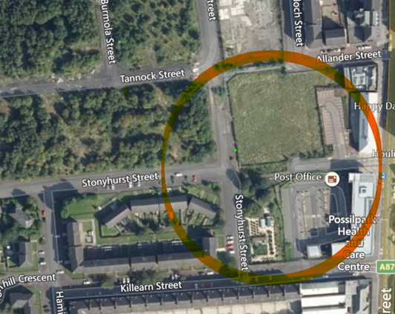
This is a Google image of an aerial shot of the proposed acquisition land.
The Back Garden (site A) sits at the bottom of the circle to the left of Possilpark Health Centre; the beds are visible just to the right of Stonyhurst Street.
The trees in that small areas mark the existing play area.
Immediately above is a large square of waste ground (site B).

Site A – The Back Garden site – Code 2301 Name BLINDCRAFT, behind the Possilpark Health Centre was formerly vacant land. This site has been used and managed by Concrete Garden (under an NHS-HSCP permission to use agreement with JBG) as the Back Garden Community Growing space since 2015, with the addition of a natural play area in 2016/17. This permission to use agreement ends in March 2023.
The proposal will see this site brought into community ownership, with the land protected as a key local resource, ensuring the longevity of the community garden site and providing local people with a meaningful stake in the future development of the Back Garden.
The garden currently has 25 large (2mx2m) and 18 smaller (1mx1m) raised bed plots, a polytunnel, a Portaloo and a container storage unit. The garden structures are nearing the end of their life span, with repair and maintenance no longer sufficient. Replacing the structures would be a significant capital project, requiring ownership of the site to gain access to the capital funding for the redevelopment work. Garden users have been preparing for this by undertaking Permaculture design training. They will use these principles to re-imagine the space with a community-led rebuild planned over 2023/24.
Most of the site is used for growing but the young people suggested that the sloped back area, which was not being used, could be a play area for them. This led to a consultation which led in turn to the young people themselves designing the area. The Natural Play Area has climbing towers, sand pits, mud kitchen, tree houses, beams, swings, slides, willow tunnel, hobbit hole and boulder climbing.
Site B – Currently a stalled space/derelict site - Code 2802 Name POSSILPARK H.S. - is currently vacant and has been since 1991/95. The former red ash playing field of Possilpark High School saw remediation work carried out in 2015/16 to excavate and remove a “mound” of debris left after the building of Saracen House. The mound was removed and capped with lime and soil and the land seeded as a meadow, with a containing wall built on Carbeth Street. The site is now overgrown with long grass. One corner is used by local people as a through path from Ardoch Street to Carbeth Street.
The site has meanwhile use and can be used for outdoor play under a temporary licence to occupy until it can be purchased. Concrete Garden has Area Committee funding to fence off part of the area and bring in a big shipping container (for storage, etc).
The proposal will see this land brought into community use to allow the expansion to meet the exponential growth in demand for outdoor play and learning services. Regeneration of the local area will see over 600 new homes (developed by Queen’s Cross Housing Association) built in the immediate vicinity of the site which will further increase demand for play services.
The current site is too small and shares the space with the community garden, limiting the days and times it is available for children to play. Community ambitions for this site include the development of a purpose-built adventure playground and outdoor early years and after school play space.
Neither site has planning permission in place.
Concrete Garden started to ask Jobs & Business Glasgow about the possibility of asset transfer in 2017. The initial response was that they planned to sell off the site for development but they are now willing to consider a negotiated sale. Discussions are positive and indicate that there is route to ownership for Concrete Garden and that JBG are willing to engage with Concrete Garden as potential owners of either or both sites. The aim is to agree a negotiated purchase with JBG of either/both sites.

Technical work
The following technical work is being undertaken, funded by the Scottish Land Fund. This will identify any technical and environmental issues that the Board needs to be aware of, in deciding whether to go ahead with the proposed acquisition.
Site Investigation - Site B only
- Phase 1 Contaminated Land Assessment, including a review of the landowner’s previous remediation work
- Phase 2 (if Phase 1 indicates this is necessary) to ascertain if any remediation to the site is required to allow the intended project use
- Topographical survey
- Understanding of environmental issues to consider regarding the intended site use and planning permission requirements
- Next steps and indicative costs to address contamination remediation or other environmental measures identified.
Independent Valuation – to establish the market value as a basis for negotiating the purchase price for the two sites:
- An independent valuation of market value of Site A
- An independent valuation of market value for Site B

Vision for the new space
Moving forward Concrete Garden’s focus is on using the 2 sites to address the existing and emerging needs, as identified by the community, for:
- more outdoor spaces
- more informal transition support services for trauma, rehabilitation, transitioning from prison/ residential care
- more accessible volunteering opportunities
- more safe places for children to go outdoors to play and meet their friends
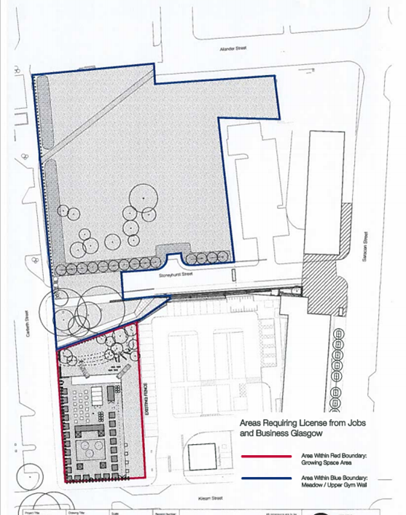
- more food growing space
- dignified food provision
Concrete Garden’s vision is, through a negotiated sale, to retain and develop the Back Garden as a community led, community owned asset and to create a purpose-built community adventure playground, alongside an outdoor early years and after school outdoor play hub on the vacant site.
This will provide much needed local services and ensure that community land is protected as a key local resource.
Through co-production, growers, volunteers, children and families from the community will lead on the design and build of the new facilities and projects that meet their needs, ensuring the longevity of both sites and providing local people with a meaningful stake in the future development of Possilpark.
The lasting impact will come from the sense of community pride and improved perceptions of the local area as a great place to live.

What growth will achieve
The acquisition and expansion will allow Concrete Garden to respond to the identified community need for: more outdoor spaces; more informal transition support services for trauma, rehabilitation, transitioning from prison/residential care; more accessible volunteering opportunities; more safe places for children to go outdoors to play and meet their friends; and more food growing space and dignified food provision.
The increased space will allow an expansion of the food and growing activities, more social activities and more volunteering opportunities.
It will have a major impact on outdoor play. The play area shares its space with the community growing project. This means play can only happen on certain days of the week. Children want to play every day. They are growing more exuberant, and, as numbers increase, so does the risk of accidental damage to beds and plants.
With 350 children registered to play and numbers increasing year on year, they have outgrown the current play space. Creating the new outdoor play area on the vacant site would give space to expand the range and frequency of play services and increase numbers.
Early consultation with the children shows that they want a new play area that has:
- More space to play
- More challenging equipment
- More space to run
- Ability to transform
- Place to rest or sleep
- Space to cook and eat
They want the playground to be accessible, transformational and adaptable; they want to be able to take it apart and build it again in a new way at any time.
They do not want to be passive observers; they want to design and build it themselves with the support of the community.

Impact on the community
Everything Concrete Garden does is founded on conversation, consultation and feedback from the community, enabling people to work together to address local needs and create positive and meaningful community resources.
Many participants are socially isolated, some are unemployed and cannot work because of health challenges or do not have the right to work. This leads to a sense of a lack of purpose and loss of meaningful activity. Participants say that having the opportunity to be part of the project and contribute meaningfully has been hugely significant, in some cases a life saver. It provides a sense of purpose, a place to go, and a source of pride from new skills, having their own plot or volunteering.
The land acquisition and the expansion that ownership will allow will result in:
- Stronger connections between people in the community as they come together to work for a common cause, building something that leaves a legacy and benefits everyone
- A greater appreciation of place and space, as people see what can be done with derelict land
- An increase in social trust, cohesion, and feeling of belonging
- More people participating in community life, arts and culture
- People carrying over the skills they learn into their own lives and network, creating a cumulative resilience
- Opportunities for local employment and volunteering
- Positive impact on physical and mental health, with less loneliness and social isolation
All of the outcomes fit with policies of Placemaking, Community Empowerment and Community Wealth Building.

Back Garden options
The community consultation (see section 5) shows the wholehearted support for the Back Garden with many examples of the difference that coming along there has made to people’s lives. The thought of not being able to come to the Back Garden is devastating for many. This support is shared by stakeholders who recognise the amazing work that it being done there.
As someone with no connection to the Concrete Garden or the community, what struck me most about the Back Garden is how well it works – a calm, welcoming, safe place where people can engage in meaningful activity, chat and grow connections as well as plants. It is a real community project – welcoming people of all ages, cultures and experiences, a mix of people who have family connections to the area going back generations to New Scots keen to integrate into their new community. It is a great example of a project that builds community.
JBG wants to sell the site. If it is sold to anyone other than the Concrete Garden, the Back Garden would lose its home and the community would lose a well-used and much loved asset.
The priority has to be to save the Back Garden and to continue its current use as a gardening/growing project because of its value, not just to participants but to the whole community.
It also contributes to wider policy aims and objectives by:
Tackling poverty and disadvantage
- Data around poverty, health, education, employment, and the environment show the intersection of these inequalities which means that people in areas of relative deprivation like the Possilpark community consistently experience greater disadvantage. The work in the Back Garden tackles health, and economic and social deprivation directly.
- The Back Garden offers individuals and families free access to garden plots where they are supported to grow their own food, take part in outdoor cookery classes or join monthly community meals.
- The work promotes wellness by encouraging healthy behaviours - more time outdoors, increased physical activity, access to healthy foods, and greater social connection, all of which improve health and well-being.
- The volunteer support and training allows people at all stages of their lives to grow personally and professionally, learning new skills and raising aspirations. From volunteering, many have gained skills/experience which has been a stepping stone leading to other roles, employment, or on to further education. This allows some to move (back) into paid employment which has economic benefits for the individual, their household and the local economy.

Community and environmental regeneration
- Social equality and greater community cohesion - Creating community spaces where people from all walks of life, cultures and backgrounds can meet socially builds a greater sense of belonging and social inclusion. Connections are essential to social wellbeing and projects such as this nurture respect for others and their needs, creating spaces for authentic interaction which in turn reduce racism, stigma, violence, and crime.
- Environmental wellbeing - By nurturing safe, stimulating and sustainable community growing space, people in a built up urban area have the opportunity to appreciate and interact with the soil and nature – good for the wellbeing of both the individual and the land.
- Activities at the Back Garden raise awareness of the human impact on the environment, actively engaging the community in environmentally friendly behaviours such as community food growing; reduce, reuse, and recycle projects; local food distribution; community composting; and active travel.
- Children and young people living in a deprived urban environment get the opportunity to learn about growing, appreciate and feel more connected to nature and understand how their actions impact on the natural world.
Acquiring the site is essential to safeguard the future of the Back Garden and ensure the continuation and the longevity of the Back Garden and its activities, so that it can continue to respond to the demand from local people for individual and communal food growing space, a meaningful stake in the future development of their garden and supporting community based, formal and informal education and training for future generations.

Play area options
The play area currently shares the Back Garden and has made creative use of the space at the end of the Back Garden to create a compact play space that allows the young people to play freely and imaginatively. It offers a safe, neutral outdoor space where young people can integrate, play and meet new friends, supported by a play team experienced in encouraging young people to play freely and express themselves.
Local families benefit from free after school play sessions where their children can be cared for safely, supported to flourish, make new friends, and experience new things.
The consultation work with the young people themselves and joining some of the play sessions show how much the young people enjoy the opportunity for free play. They and their families and the wider community want to see the play space retained, as it is much valued as a safe space for them to play and be themselves.
The young people are excited by the prospect of having an additional space, especially one where they will be able to lead on the design and development of the space. They want to see it developed as an outdoor adventure play space that remains ‘theirs’, not something created for them by someone else, and recognise that this will not all happen at once but will be a gradual process. Everyone just likes the idea of having more space to play.
If the Back Garden is lost, the play service would have to find an alternative base which, given the lack of local greenspace would be difficult. The only alternative would be to use existing outdoor space, such as parks, which would limit activities and would be unlikely to be as accessible for the young people who are currently able to come along by themselves. This builds on the case for purchasing the Back Garden site.

The main challenge with using the Back Garden for the play activities is that there is not enough space, and time is limited by use of the garden by growers. Buying Site B would give a big, open green space for play. The site can be developed for outdoor/adventure play as and when funding allows.
This site is currently vacant and derelict, with limited use by local people for dog walking and as a cut through. A key element of developing this site would be to ensure ongoing community access. This will involve fencing off some of the area as a dedicated play space and leaving part of the site open for wider public access and use, including use by the young people themselves outwith play session times.
The intention is to ensure that after school and holiday play sessions remain free for kids in the local community, but acquiring and developing the additional space creates opportunities to generate income from other sources such as day-time use by childminders, nurseries or other organisations, or from training other playworkers and teachers in outdoor play skills.
The additional play space will allow more play sessions and more kids per session. It is recognised that this can only be done by increasing the number of play staff to cover the additional hours required to plan and deliver these services at the current high standard. However it is the quality of the services, the nature of the play and the positive interaction with the young people that makes this an attractive job for the calibre of playworkers who will ensure the continuation of vibrant play services.

Consideration of options
The previous sections have set out the case for the acquisition of the sites and the expansion of services that this will allow over the coming years. This section considers each of the options for the development of both sites - short, medium and long-term – including high level assessment of each activity for operational and financial viability; the need addressed and the difference it will make for the community.
The option recommended must also fit with Concrete Garden’s charitable objects which are stated as:
To promote for the benefit of the public the advancement of citizenship, civic responsibility, sustainable community development and urban regeneration of the community of Possilpark and the wider North Glasgow Area
4.1 To provide recreational activities with the object of improving the conditions of life for the persons for whom the activities and facilities are intended
4.2 To advance environmental protection, improvement and education to all people.
Option 1: Acquire the land
Option 1 is to acquire one or both sites from JBG at a fair market price to allow the continuation and upgrade of the Back Garden site and the expansion of the outdoor play activities on the new and bigger site.
Fit within Concrete Garden’s aims and objectives – This clearly fits with all of the elements within the charitable objects and with the aims and objectives of supporting the growth of a happy, healthy, and thriving outdoor community, by creating opportunities to grow, work, socialise, play and learn together.
Operational and financial viability
The Back Garden is already operationally and financially sustainable, so owning the land can only impact positively on this as it allows for longer term planning and working towards elements of income generation.

The play area is also operating successfully in the Back Garden. It is recognised that taking on the larger site is an exciting opportunity to develop an imaginative play offering. The space is currently unused and derelict. The first priority would be to make it safe for the young people to play on and access; beyond that, development of play areas and the addition of play and storage equipment (all of which would need to be ‘temporary’) can be done gradually over time, as and when funding allows and within organisational and management capacity.
The acquisition will open up opportunities to secure the capital funding that will be required to redevelop the Back Garden and develop the play space. Funders look for ownership of the asset or at least a secure long-term lease before they will consider applications for this capital funding.
The Back Garden site demonstrates that derelict land can and does contribute to the economic development of Possilpark and is an example of what can be achieved on the neighbouring site B. Both projects are currently sustainable through grant funding. Possilpark is statistically one of the areas of greatest deprivation which means that, although there is a lot of work involved in securing grant funding, it is likely that there will continue to be funding available for the foreseeable future that will allow the organisation to continue to deliver its core garden and play services free to its community beneficiaries.
Tit is recognised that the amount of grant funding will increase with the additional staffing required to ensure that there is organisational capacity to deal with the additional work involved in the land acquisition, development and subsequent growth in services. This is considered later in the feasibility study.
By providing a physical base for community gardening and dedicated outdoor play and learning services, the land acquisition will open opportunities for the development of projects and services that generate income, which can contribute to financial sustainability in the longer term.
The site acquisition will enable a people-centred approach, placing the control and benefits of these outdoor assets into the hands of local people. It is recognised that it may need longer than 3 years to fully develop both sites but the aim is that the projects and assets developed will be self-sustaining over time.
The need addressed and the difference it will make for the community
A combination of Covid lockdowns and the increasing awareness of the environment has changed people’s attitudes and increased demand for more outdoor community spaces and places to come together. People want to see more activities connected with food and outdoor space.
Demand for outdoor play is increasing, especially provision of safe outdoor spaces that encourage adventurous play.
The proposed acquisition addresses the following service gaps identified in consultation with the community:
Back Garden
- Activities and services that support local people to become involved in outdoor pursuits
- Availability of space for food growing and dignified food provision
- Quality, accessible outdoor facilities and open spaces
- Availability of neutral outdoor spaces where people can integrate, meet new friends, or connect with neighbours

Larger play area
- Open spaces for outdoor play – places set aside and protected for children
- Quality, accessible outdoor facilities and open spaces to play
- Availability of neutral outdoor spaces where young people can integrate, play and meet new friends
The community is at the heart of all of Concrete Garden’s projects, and community consultation showed that the Back Garden is at the heart of the community. Community led regeneration will be the catalyst for change, transforming and re-imagining these two sites (one currently derelict), bringing them into community ownership as active, vibrant, and valued community assets, enhancing the experience of all people living in Possilpark, and reducing disadvantage by creating space for recreation and wellbeing.
It will also mean the continuation of opportunities for volunteers and potential for creation of more jobs and training places for local people, all of which improve individual life chances and create greater community resilience.
The Back Garden starts from a strong environmental perspective, encouraging not just organic growing but understanding of wider environmental impacts and steps to lead less wasteful, more environmentally sustainable lifestyles. This raised awareness means that people realise the need to protect and promote urban greenspaces, particularly those that they value in their community.
As well as an eyesore, vacant and derelict land can be an environmental hazard from a toxicological perspective - dog fouling, littering and fly tipping. Bringing Site B back into active community use reduces these risks.
Other environmental benefits of acquisition come from maintaining both sites as community greenspace which forms part of the green corridor, a key part of the Local Development plan.
One of the key aims for the development of both sites is to be net zero or carbon negative through use of reclaimed materials, composting, etc.
The proposed land acquisition will provide the space to scale up sustainably to ensure the Back Garden and the play activities keep doing what they are recognised by the community as being good at and continue to address the needs identified.
Experience in the Back Garden has shown what works – and what doesn’t work - in terms of space. This knowledge will be invaluable in planning how to make best use of both the existing Back Garden and a new additional outdoor play space. As an organisation, Concrete Garden has the skills and experience to work with the community to design and lead the development of the new space.
The community consultation work, both for this feasibility study and carried out on an ongoing basis by Concrete Garden, shows how much people value and, in many cases, rely on the Back Garden for their wellbeing, both physical and mental, and for social and community connection. Many of these people, through life circumstances, have become disconnected from their community or find themselves faced with language and cultural differences in a new community. The Back Garden has been that welcome open door for them. The loss of community use of the Back Garden and outdoor play area, should the community not be able to purchase or continue using the site, would be devastating for many of the most vulnerable people and families in the local community.
This is the recommended option – for all of the reasons shown above.
Option 2: Continue in the Back Garden site under a licence to occupy
This amounts to a ‘do nothing’ option as JCB have stated that they want to sell the sites. If Concrete Garden does nothing and the Back Garden site is sold to another purchaser, the option to occupy the site under the existing or any licence will no longer exist and the Back Garden and the play services will be homeless.
This would be a massive loss for the community.
It would also severely reduce the scale and scope of operations for Concrete Garden, impacting on operational and financial viability.
This option is of no benefit to either the organisation or the community.

Option 3: As part of larger Levelling Up bid
Glasgow City Council is looking to submit a £19.3m bid to the Levelling Up Fund for Possilpark. This could potentially include the purchase of the two sites for the community which would be spade ready projects as part of the bid. It would be part of the creation of a green route/corridor with other projects.
Collective Architecture are assisting with the bid but there are no firm proposals to include the acquisition of Site A or B in the bid.
The risk for Concrete Garden of being part of a larger bid is that they lose ownership of the design and development of the 2 sites. It is essential that the sites are developed, led by what local people want, not architect designed and imposed on them. The Back Garden had to redesign its site to make it work for them, hence the training to be able to undertake the proposed community-led redevelopment. The play area is about giving the young people a piece of land in their community and letting them decide on the use and design.
If the say in how the sites look and operate is taken from the community, the risk is that they no longer feel that it is theirs and disengage, both as participants and as volunteers. The sites then cease to serve their purpose and also risk not being operationally or financially viable.
This option does not work in the best interests of the community or the organisation.

Option 4: Look for another site
This feasibility study did not include work to try to identify another potential site, mainly because Concrete Garden’s knowledge of the area and the regeneration plans suggest that there is not another suitable site, and certainly none in the immediate Possilpark area.
Indications are that JBG are willing to sell the site to Concrete Garden, assuming that terms can be agreed and the funding secured to cover the purchase price.
If the purchase does not go ahead, Concrete Garden will be faced with the necessity of finding an alternative site or scaling down operations to what can be delivered from the site at the St Matthews Centre.
Only at that point will this become an option.

Recommendations as to the preferred use(s)
Site A – The Back Garden site
The argument for a purchase of the Back Garden space is the unequivocal need to save this established and much appreciated green space for community use. Purchasing the site gives Concrete Garden the security of ownership and ensures that this valued community resource is protected, secure and sustainable for plot holders and for the community in the longer term.
Ownership will allow access to capital funding to redesign the garden, using co-production and based on the experience of operating the Back Garden for a number of years. This can be done in stages over time, as capacity and funding allow.
The Back Garden is already operationally and financially sustainable, so owning the land can only impact positively on this, as it allows for longer term planning and working towards elements of income generation.
There is no good argument against going ahead with the proposed acquisition of Site A.
Site B – Additional play space
The play area is also operating successfully in the Back Garden but limited by space. The proposed land acquisition will provide the space to scale up sustainably and address the needs identified. There is no doubt about the need for and the benefits of having more space.
The space is currently unused and derelict. The first priority would be to make it safe for the young people to play on and access; beyond that development of play areas, basic infrastructure on the site and the addition of play and storage equipment (all of which would need to be ‘temporary’) can be done gradually over time, as has been the case with the organic development within the Back Garden, as and when funding allows and within organisational and management capacity.
This service is only worth expanding if it can maintain the high quality of play that it currently delivers. The feasibility and consultation work indicate that learning and knowledge gained from delivering the existing play services can be used to plan how to make best use of the new additional space, and that organisationally there is the capability to take this on and make a success of it.
Additional delivery hours/posts will be required (some now and some over time) to allow the organisation to make the most of the garden spaces and develop the play services. It is recognised that this increases the funding challenge but delivering more means achieving more outcomes and increasing the reach into and impact on what is statistically a very deprived community. The synergy between activities and the increased impact that comes from this means that projects are likely to continue to appeal to funders.
Organisational and particularly management capacity are vital for the success of the project. Recruiting a new post of Deputy Chief Executive to take on some of the Chief Executive’s current workload will ensure that there is capacity to deal with the additional work involved in the land acquisition, development and subsequent growth in services.
There is no doubt about the organisational capability and experience of working for and with its community, and the motivation for the acquisition. This, together with the enthusiasm, active participation and support from the local community will ensure the success of the development beyond acquisition.
The recommendation is the go ahead with the negotiations with Jobs and Business Glasgow to purchase both sites.

4. Market Research
This section assesses the potential and demand for Concrete Garden to develop site B as an adventure playground and outdoor early years/after school service.

Local area profile
The local area profiles show the demographics and levels of need in the area which, in turn, demonstrate the size of the potential market for both the community garden and the play activities.
Although the sites are located in postcode G22, people currently come to the Back Garden from a wider north-west Glasgow area, covering postcodes G20, G21 and G23 as well as G22.
Canal Ward 16 includes Possilpark and Milton as well as Ruchill, Firhill, Hamiltonhill, Parkhouse, Lambhill, Port Dundas and part of Cowlairs.
The key population and economic data for Canal Ward is shown in the table below. Note that the figures are based on National Records of Scotland Estimates 2015 data which will be updated when the new Census information becomes available. This is likely to show an increase in population with the new housing developments:

Total population 25,000 (estimated to have grown to 27,000 by 2020)
Pre-school, age 0-4 1,559 6.23%
Primary school, age 5-11 1,860 7.44%
Early teens, age 12-15 1,018 4.07%
Young adults, age 16-29 5,309 21.24%
Adults age 30-44 5,009 20.04%
Adults age 45-64 6,209 24.84%
Adults age 65-74 2,176 8.70%
Adults age 75+ 1,860 7.44%
The figures illustrate the young age profile of the ward, with a much higher percentage of children and young adults than many of the other areas of Scotland, most of which have an increasingly elderly population.
The lower percentage of older adults reflects the health inequalities that have plagued the area for decades and the lower than average life expectancy.

Neighbourhood Comparisons with Glasgow
The statistics below are for the smaller Ruchill and Possilpark neighbourhood (population 10,737). They show, if anything, a starker picture than for the Canal Ward and highlight the following:
- Ruchill and Possilpark had the lowest life expectancy, for both males and females, of all neighbourhoods in Glasgow in the most recent period. Although life expectancy for both males and females has risen in recent years in Ruchill and Possilpark, it remains considerably lower than the Glasgow and Scotland average.
- The average number of years that local men are likely to spend in good health is 48 (second lowest neighbourhood level in Glasgow), compared to the Glasgow average of 56, which is in turn 7 years lower than Scotland as a whole.
- Women in Ruchill and Possilpark live, on average, almost 7 years longer than men.

- For local women, healthy life expectancy is 50 years (second lowest in Glasgow), compared to 58 across the city and 64 nationally.
- More than half (52.9%) of households are single parent households, almost a third more than the Glasgow average.
- A relatively high percentage of people are also limited ‘a lot’ or ‘a little’ by a disability.
- 30% of people in the area live with a limiting long-term illness compared to 19.6% nationally.
- Environmental disadvantage impacts disproportionately on deprived urban areas, and in the area of Possilpark and Ruchill 100% of citizens are surrounded by vacant derelict land, much of which is polluted. Proximity to environmental burdens have implications for health and wellbeing, leaving communities like Possilpark at risk.
- The neighbourhood has a low employment rate compared with the rest of Glasgow (-17%) and 13% above the national average, with a high percentage of young people not in education, employment or training.
- Educational attainment remains low - 43.1% of local residents have no qualifications compared to 26.8% across Scotland.
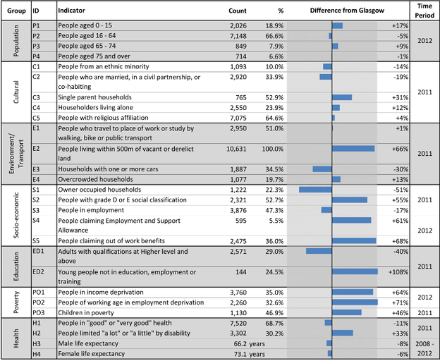
Children and Young People
Ruchill and Possilpark has a population of 3,362 children and young people (aged 0-24 years).
- The proportion of school age children in Ruchill and Possilpark is 15% higher than Glasgow as a whole.
- More than 2 in 5 children in the neighbourhood (41%) live in poverty, 40% more than in Glasgow overall.
- 40% of dependent children come from a single parent household in this area, and 40.9% of dependent children live in poverty.
- Likely development difficulties in pre-school children are lower than the Glasgow average (-44%) but communication delay in young children is higher than average (+3%).
- Levels of obesity in P1 children are 24% higher than the Glasgow average.
- Only 90.6% of children attend primary school and 87.2% attend secondary.
- S4 pupil attainment is lower (-28%) than the Glasgow average and approximately 50% of 16-19 year olds are not in employment, education or training.
- The neighbourhood has more referrals to the Scottish Children’s Reporter Administration (+103%), and more young offenders (+74%)
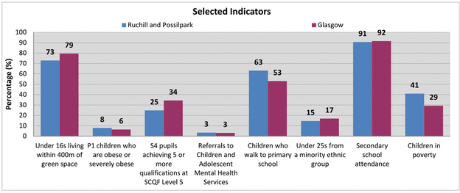
All of these statistics show the need for both the Back Garden and the play activities in terms of improving the levels of activity and physical and mental wellbeing of local people of all ages, giving them a chance at a better quality of life.

Deprivation
The Scottish Index of Multiple Deprivation (SIMD) is a Scottish Government assessment tool, using a range of socio-economic data to calculate deprivation. It provides an analysis of deprivation based on 6,976 small areas across Scotland known as data zones (approximately 700 people). The index ranks the datazones from most to least deprived based on 7 aspects of deprivation – Income, Employment, Health, Education, Access to services, Crime, and Housing – as well as giving an overall picture for the area.
SIMD 2020 headline figures in the table below show that:
- Possilpark has been ranked in the 5% most deprived areas in Scotland since the Scottish Index of Multiple Deprivation (SIMD) began in 2004.
- Possilpark currently contains the most deprived datazone (S01010323) in the whole of Scotland in terms of both income and health (no doubt interrelated). Ranked at 6 in terms of employment and overall at 12, it is ranked in the 5% most deprived in all indicators, other than access to services.
- Possilpark has another datazone (S01010326) ranked not far behind at 14 and in the most deprived 1% in terms of income, employment, health and education.
- The Keppochhill datazone S01010312 also ranks really poorly, particularly in terms of health (8th), income (13th) and employment (20th)
Datazone | DZ name | SIMD2020 Rank | Income | Employment | Education | Health | Crime | Housing
S01010323 | Possil Park - 01 | 12 | 1 | 6 | 328 | 1 | 291 | 241
S01010326 | Possil Park - 04 | 14 | 21 | 54 | 47 | 33 | 134 | 395
S01010312 | Keppochhill - 04 | 33 | 13 | 20 | 788 | 8 | 706 | 294
S01010313 | Keppochhill - 05 | 118 | 63 | 116 | 695 | 79 | 1656 | 354
S01010311 | Keppochhill - 03 | 167 | 183 | 349 | 117 | 150 | 154 | 369
S01010316 | Ruchill - 02 | 182 | 136 | 212 | 447 | 203 | 708 | 609
While this data paints a bleak picture, what it fails to capture is the positive community spirit in Possilpark. There are strong associational ties and bonds which exist in the area between families and neighbours, and there is an enthusiasm to volunteer and contribute to local projects and initiatives that work to address local challenges and create positive community spaces.
The community is changing, with 2,000 new homes being built over the next 5 years, highlighting an even greater need for services that support people to integrate and become involved in local life, especially for marginalised people.

Evidence of need
The community has been the subject of numerous consultations. A summary of these, produced by Glasgow CPP, highlights the following needs:
- Better community spirit through regular social events / developing community space
- Better integration of long-time residents and newcomers
- More activities and events
- More investment in physical assets
- More to tackle anti-social behaviour
- More for kids in the area - there is a lack of quality facilities for sports, recreation and children’s play in the area.
The Back Garden and the play area help to address some of the challenges faced by people in the community:
- Social isolation - with a higher risk of social isolation among older residents, those in recovery or experiencing mental ill health/disability/ long-term illness and the BME community
- Health - 30% live with a limiting long-term illness (19.6% nationally)
- Education - Attainment is low with 43.1% of residents having no qualifications (26.8% nationally)
- Positive integration – This is an increasingly diverse community, as was evident from the Open Days
- Safety – People don’t feel safe, fear knife crime, feel isolated; children don’t have anywhere safe to play outdoors.
- Lack of greenspace, garden space, food growing space and the opportunity to get outdoors and connect with nature.

Competitive analysis
Concrete Garden’s work complements and adds value to a wide range of local services and provision, statutory, private and voluntary sector.
Local nurseries, schools, ASN schools, other youth organisations might be either users, potential partners or opponents/competition for the enlarged play area and for visits to the Back Garden.
Schools - Keppoch Campus, opened in 2004, brought together Saracen and Hawthorn Primary Schools (school capacity 330; current role 229), St. Theresa’s RC PS school (capacity 217; current role 160), Broomlea School for pupils with complex additional support needs, as well as Keppoch Nursery and Stepping Stones Family Learning Centre whose services include Ardoch Childcare Centre and Possilpark Out of School Care.
GCC Education Services has 110 Early Years Nurseries and there are another 345 private and voluntary childcare providers throughout the City (including private nurseries, playgroups, child minders, Out of School Care and crèche facilities). That, in itself shows the size of the potential market for play services, especially if they offer something different to the standard statutory provision.
As well as Council provision, Glasgow City Council services work in partnership with private and social economy sector Early Years’ services to extend parents’ choice for pre-school education and childcare. They commission a number of fixed places from partner providers through these framework contracts.
A search of Early Years’ provision in the postcode areas shows that 769 registered places are available locally as follows:
Name | Type of provision | Available | No of reg’d places | Contact details
Balmore Kindergarten  Balmore Industrial Estate, G22 7XS | Private | Mon to Fri 8am to 6pm  Breakfast club 7:30am to 8am | Age 0-2: 12 places  Age 2-3: 24 places  Age 3-5: 56 places  Age 5+: 32 places | Contact: Laura Taylor  Tel: 01413364111  Email:laura@balmorekindergarten.co.uk  Website: https://www.balmorekindergarten.co.uk
Milton Community Nursery  St Monica's (Milton) Primary, Liddesdale Road, G22 7QR | Council | Mon to Fri 8am to 6pm | Age 0-2: 12 places  Age 2-3: 20 places  Age 3-5: 55 places | Contact: Shona Young  Tel: 01417726319  Email: headteacher@milton-nursery.glasgow.sch.uk  Website: https://blogs.glowscotland.org.uk/gc/miltoncommunitynursery
Stepping Stones for Families - Ardoch Childcare Centre  Bardowie Street, Possilpark, G22 5AA | Voluntary sector | Mon to Fri 8am to 5.30pm | Age 0-2: 12 places  Age 2-3: 10 places  Age 3-5: 20 places | Contact: Angela Rushton-Clark  Tel: 01413365419  Email: acc@ssff.org.uk  Website: www.ssff.org.uk
Stepping Stones for Families - Possilpark Family Centre  Keppoch Campus | Voluntary sector | Mon to Fri 9:45am - 2:45pm | Age 0-2: 16 places  Age 2-3: 10 places | Contact: Claire Kilfedder  Tel: 01413362129  Email: claire.pfc@ssff.org.uk  Website: www.ssff.org.uk
Keppoch Nursery School  Keppoch Campus, G22 5AX | Council | Mon to Fri 8am to 6pm | Age 3-5: 80 places | Contact: Kelly McLaughlin  Tel: 01413367750  Email: headteacher@keppoch-nursery.glasgow.sch.uk
Scaraway Nursery School  Shapinsay Street, Milton, G22 7JW | Council | Mon to Fri 8am to 6pm | Age 2-3: 15 places  Age 3-5: 80 places | Contact: Gail Kelly  Tel: 01417721604  Email: headteacher@scaraway-nursery.glasgow.sch.uk  Website: www.glasgow.gov.uk/education
Benview Early Years Centre  Benview Campus, Bilsland Avenue, G20 9NY | Council | Mon to Fri 8am to 6pm | Age 2-3: 15 places  Age 3-5: 40 places | Contact: Josephine Wood  Tel: 01419464740  Email: headteacher@benview-nursery.glasgow.sch.uk  Website: www.benview-nursery.glasgow.sch.uk/
Ruchill Early Years Centre  Smeaton Street, G20 9JS | Council | Mon to Fri 8am to 6pm | Age 0-2: 9 places  Age 2-3: 17 places  Age 3-5: 30 places | Contact: Susan Donaldson  Tel: 01419451886  Email: headteacher@ruchill-nursery.glasgow.sch.uk  Website: www.glasgow.gov.uk/education
Hamiltonhill Family Learning Centre  Ellesmere Street, G22 5QT | Council | Mon to Fri 8am to 6pm | Age 0-2: 21 places  Age 2-3: 18 places  Age 3-5: 50 places | Contact: Frances Stokes  Tel: 01413322797  Email: headteacher@hamiltonhill-nursery.glasgow.sch.uk  Website: www.hamiltonhill-nursery.glasgow.sch.uk
Maryhill Mobile Children's Service  Provide crèches Glasgow-wide (and its boundaries) | Voluntary sector | Mon to Sun 9am to 9pm | Age 0-2: 9 places  Age 2-3: 17 places  Age 3-5: 30 places  Children can attend from 0-16 years (18 years with add’n needs) | Contact: Caroline Thomson  Tel: 01419451888  Email:caroline.thomson@btconnect.com  Website: www.mmcs.org.uk
Evergreen Outdoor Nursery  (part of Maryhill Mobile Children’s Services - see more info below) | Voluntary sector | Mon to Thur 8am to 6pm | Age 2-5: 20 funded places | Contact: Sharon Pebbles  Tel: 07565869427  Email: evergreenon@outlook.com  Website: https://www.mmcs.org.uk/outdoor-nursery
West End Nursery  Malloch Street, G20 8TP | Private |  | Age 0-2: 15 places  Age 2-3: 10 places  Age 3-5: 14 places | Contact: Amanda Tough  Tel: 01419455179/07706120459  Email:westendnurseryglasgow@gmail.com  Website: www.westend-nursery.co.uk
As well as the funded provision shown above, Stepping Stones for Families provides an Out of School Care service and childcare services in the family home – early morning, after school, in the evenings and at weekends. This service is also available for respite for families with a child / children with additional support needs.
Other providers noted in a web search include:
- Positive Possilpark (Community Family Support and Development Possilpark). It is noted that they pay sessional childcare workers (SCQF Level 7) £9.90 /hour.
- Rainbow Dreams Day Nursery, 139 Barloch St, Glasgow G22 5LE. A 0-5 year old nursery open all year round Monday to Friday 7.30 am to 6.30 pm. They offer risky play, constructive play, fantasy play, social play, exploratory play. Funded places are available for all 3-5’s and eligible 2’s; otherwise childcare fees are £25 for a morning or an afternoon. https://www.facebook.com/RainbowDreamsDayNurseryPossilpark/
Concrete Garden is one of a very small number of local organisations that offers Forest school and specific outdoor play and learning services. Similar services offered elsewhere in the City include:
Evergreen Outdoor Nursery, part of Maryhill Mobile Children’s Services, originally set up as a mobile crèche by local volunteer mothers looking to access community learning projects. The organisation has grown considerably and now operates a mobile crèche supporting voluntary organisations city wide; a respite service for vulnerable families with children aged 0-3 years; Dunard After School Care (est. 2011); Evergreen Outdoor Nursery (est. 2015); St Charles ASC (opened March 2020); Tree Top Outdoor Nursery (opened March 2022) with plans for North Kelvinside After School Care Service.
Evergreen Outdoor Nursery is based at Dawsholm Park (G61 1QG) but may visit other Glasgow parks depending on the day’s topic. Rainproof suits and backpacks are provided.
They work within the Curriculum for Excellence and realising ambition frameworks. Glasgow City Council Partnership places available – 1,140 hrs. Other places are £45/day.
​​Tree Top Outdoor Nursery opened in March 2022 within Cadder Primary school. It is open Thursday and Friday 9.15am - 5.15pm and operates similarly to Evergreen.

Growing projects
Concrete Garden and the Back Garden are the only service in the immediate neighbourhood to offer free, supported social and therapeutic horticulture for adults, giving them free access to their own bit of green space, free resources and equipment, training and support from skilled staff.
Other community gardens in north-west Glasgow include:
Woodlands Community Garden opened in 2010, occupying a vacant site in West Princes Street (G4 9BY). It now has raised beds for 50 households to grow their own produce and a waiting list for community beds. They have Community Garden Open Afternoons on Sundays 1-4pm plus other volunteer garden sessions, currently on Tuesday mornings.
Willowbank Garden is a smaller garden that they adopted in 2016 to preserve and maintain an attractive greenspace for local residents. Weekly drop-in garden volunteer session are held at Willowbank Garden, every Thursday from 5 - 7pm. Tasks are mainly tidying, weeding, pruning and watering. Volunteers do not need any previous gardening experience as instructions are given.
They have developed a terrace area at Ashley Street (G3 6HW) which is used for activities and events and for the Community Café on the Terrace every Sunday afternoon from 1-4pm. The cafe is run on a drop-in basis, serving soup and bread, tea, coffee and cakes (all vegan with gluten free options). It operates on a ‘pay what you can afford’ basis.
Other activities and ideas that might be of interest to Concrete Garden:
- Little Baby Garden Group meets weekly on Monday mornings on their outdoor Events Terrace.
- Wee Blether Playgroup meets on Tuesday mornings at the Community Garden.
- Women of Woodlands Support Group, initially set up to help the community recover from the trauma of the murder of Esther Brown, meets Monday afternoons and offers a safe, friendly and welcoming space for local women. The group helps facilitates a programme of community mental health and well-being activities for local women, as well as providing training and a space for women to reflect on issues relating to campaigning, criminal justice reform and community safety.
- Free Nurture through Nature Support Service with Judy Jamieson, a local mental health specialist, in one of a number of green spaces in and around the Woodlands Community Garden.
- WOCO is Woodlands’ community festival with music, family activities, wellbeing activities and a marketplace. It is free, part funded by a WOCO prize draw (tickets/donations £5, £10, £15 or £20). The website also allows people to make a one-off donation, become a ‘Friend’ or be a business/group supporter.
- A seasonal Fruit and Veg Box Scheme, available fortnightly for local people, on a ‘pay what you can afford’ basis, so that those impacted by the cost of living crisis and struggling financially do not have to pay anything.
- They are setting up a Community E-Bike Scheme so that people can hire one of their two E Cargo Bikes.
https://www.woodlandscommunity.org.uk/

Maryhill Park Community Garden
In 2016 a small group of volunteers from Friends of Maryhill Park, with support from the GCC Stalled Spaces initiative, set about cleaning up and refurbishing the site, adjacent to the old bowling greens and tennis courts in Maryhill Park, as a community growing space.
It is open any time for people to come in. Volunteers are usually working there, or in the park nearby, most Sunday afternoons, 2-4pm
Facilities include raised beds (“Adopt-a-Bed“); a secure “garden shed”, with access to tools and equipment by arrangement; a custom-built shelter/gazebo with integral water tower for rainwater collection; a wildflower bed; a bug hotel; a rockery and a compost heap.
Like the Back Garden, they use locally-resourced/recycled materials, wherever possible, to construct various features. Raised beds are made from used scaffold boards. Gazebos and growing frames are purpose built from scaffold poles and rebar mesh. The “garden shed” is a secure, heavy-duty steel shipping container, and the water tower is made from used 45 gallon drums, originally used for importing orange juice. The rockery area uses old sandstone blocks from a local chimney that had to be demolished.
The heavy-duty steel utilities cabinet, part of the original structure, proved too difficult to shift and has been re-purposed as a multi-story bug hotel using leftover paving blocks and the enthusiastic dry-stone walling techniques of a friendly local stonemason.
They are continuing to develop the site, adding new beds and other features as they go along, learning from experience what works best.
http://www.maryhillpark.org/active-life/community-garden/

Braeside Community Garden is on a gap site backing onto the Canal, on Maryhill Road, near Queen’s Cross. A few years ago, funding was obtained from the charity Dot-to-Dot to bring the space back into use after decades of dereliction and fly-tipping. A group of volunteers, using mainly recycled materials, gradually made the site usable. It now has a number of raised beds for food growing and a number of saplings were planted to start an orchard.
Over the past year, it developed an area for organised play, with a tree house and sandpit created for infants and families.
A monthly ‘Maker’s Market’ provides some income, as well as an opportunity for local makers to sell locally.
https://www.facebook.com/Braeside-Community-Garden-112757840994038/

Sandy Road Community Garden in Partick (G11 6RR) was set up and is led by a committee of volunteers, with support from Partick Housing Association and the NHS. It has raised beds and communal growing spaces for members.

Gathering Ground is a new community food space at Old Basin House on Applecross Street (G4 9SP), launched in Spring 2022 to create a gathering space that uses food as a platform to impact the community, build connections and encourage creative learning.
The aim is to host food focused events that celebrate diversity and collaboration, and promote organic growing methods and environmentally sustainable practices. The plan is to offer a mix of programmes and events, ranging from supper clubs, storytelling and music nights, to poetry, and a variety of talks, courses and creative workshops.
The open-plan space at Old Basin House can also be booked for small scale one-off events, regular classes, workshops and meetings.
Their website says they are looking for collaboration opportunities.
https://www.gatheringground.org/

Partnership working
One of the keys to Concrete Garden’s success is that they work in partnership with local organisations to ensure opportunities are accessible and to reach people who may need additional support to get involved.
Concrete Garden practise a joined-up approach to work and the wider community by staying connected via networks and partnerships, working collectively, and strengthening each other. They have active partnerships with:

Partner | Current relationship | Opportunities
Referral partners including Glasgow Health & Social Care Partnership, Faith in Throughcare, The Rowanbank Clinic, Occupational Therapists (including those working with the Community Mental Health Team) and local branches of Restart (NHS project working with adults with enduring mental ill health), Penumbra, Phoenix Futures, The Disability Trust, SAMH and Breathing Space | - Referral pathways for volunteer taster sessions and interest visits through organisations working with the most vulnerable and hardest to engage people  - Hosting tasters for these groups and visit groups to share information and run activities | - These and others will continue to be referral partners.
NHS and Possilpark Health and Care Centre  The Back Garden sits behind so there is a close physical and working relationship | - Referral pathways with occupational therapists offering the garden as a therapeutic resource for play and social prescribing for clients  - Members of and attend monthly “Community Orientated Primary Care” network meetings and “Making Connections” meetings | - Using the success stories of referrals to date, the aim is to work more closely with the Health Improvement leads to reach out to more health practitioners within the centre, making them aware of what the Back Garden can offer their patients.
Possilpark Young People and Families Group (YP&F), a motivated group of local people, community organisations and businesses. Current members include representation from – HSCP -Youth Health Services, Social Work, Youth Justice and the Health Improvement Team, Young People’s Futures, Action for Children, NG Homes, Glasgow Life, Clay Community Church, St Matthew’s Centre, GCC Neighbourhood and Sustainable Communities Team, Police Local Problem-Solving Team, Local elected members | - Shared joined-up approach towards meeting the needs of local young people and families and supporting them to meaningfully participate  - They support the vision of a Possilpark outdoor play plan, and dream of creating an adventure playground. | - Partnership opportunities through outdoor play – provision of outdoor play space; provision of training or practitioner peer to peer learning
Ruchill and Possilpark Thriving Places Group working towards ‘Our Community Plan’ produced by people who live or work in Ruchill and Possilpark, using an Asset Based Community Development approach. | - Shared commitment to tackling inequality in Ruchill and Possilpark  - Shared focus on building strong partnerships, building social capital and focusing on preventative measures | - They support the project ideas both for the Back Garden and for a new Possilpark outdoor play plan, and are advocates for CG’s Outdoor Community ambitions.
Informal partnerships with local organisations and health providers –The Grove, Richmond Fellowship Trust, Graham Anderson House, Enable and Rape Crisis | - Delivering sessions for recovery groups | - Work to develop these partnerships more formally, and put in place services that are mutually beneficial
St Matthew’s Centre, a resource focusing on those most in need.  For decades, the Centre has supported people experiencing addiction issues, people experiencing homelessness, and ex-offenders through support groups and lunch clubs. It has a growing community-based programme including dance, yoga, knitting, and community meals. | - Concrete Garden are based in their building and work in partnership with them.  - Collaboration on the Community Kitchen project, set up to host community meals and coordinate a FareShare membership, enabling food access for cookery activities, community meals and lunch clubs for various groups | - Concrete Garden hope to continue to be based in the St Matthew’s Centre and work in partnership for the benefit of the community.
Therapeutic Garden Network and other partners | - Shared knowledge and mutual support | - Continued sharing of knowledge
Supported living providers (SAMH, Crossreach, The Mungo Foundation) | - Provision of growing kits and resources to get residents involved in growing | - Ability to bring people into the Back Garden if it can be made fully accessible
Local schools | - Involvement in community projects  - Play referrals | - PEF funded outdoor play or Forest School sessions  - Outdoor classroom options for space on the new site  - Curriculum for Excellence informed lessons
Volunteer Glasgow and North West Voluntary Sector Network | - They refer volunteers to the Back Garden.  - They provide training and support to build volunteer capacity. | - Continuation of same
Glasgow Kelvin College | - Training partners who deliver REHIS, First Aid, and Health and Safety courses, etc. | - Plans to expand this into SQA accreditation for CG’s own training
Play Partner | Current relationship | Opportunities
HSCP Health Improvement team | - Financial and organisational support  - A close working relationship with them to further the Back Garden as a therapeutic resource for play and social prescription for their service users and clients | - More social prescribing  - Closer links with OHS – for children
YPF (Young People’s Futures) | - Supported the distribution of 700 activity, arts and gift packs during CV-19 | - Peer to Peer practitioner learning
North West Youth Network and Youth Scotland | - Connection and links to local and national opportunities for young people and youth workers | - Continued links for youth workers and volunteer development
The Smart Play Network, GCC Community Play Services, Youth Scotland Digital Forum and NSPCC | - Peer support, advice or training | - Continued mutual support, advice and training as play services develop
Glasgow Science Centre Community worker | - Opportunities for young people to visit and utilise resources | - Festival and S.T.E.A.M sessions/activities in the new Play Space
Early Years and Nursery | - PEF funded sessions  - Class/group visits | - More formal partnerships  - New site partnership potential  - Outdoor early years and after school services from the site

Policy fit
Concrete Garden’s activities, both in the Back Garden and the play space, contribute to the following policy areas:
Policy | How the proposals contribute
Thriving Places ‘Our community plan' | - Supporting people to feel stronger, safer, healthier, happier and included  - Nurturing community connections through social events, activities and opportunities  - Focused on early intervention and prevention of antisocial behaviour through outdoor play and learning
Community Planning Partnership Community Plan - Resilient Communities | - Providing wide reaching and meaningful community engagement
Community Empowerment | - Taking ownership of and transforming vacant land for community and environmental benefit  - Empowering local people of all ages to have a real say through participatory design in the development and design of the garden, play area and the projects  - Giving local people a voice in other local developments through working groups, participatory budgets
Scottish Government Regeneration Strategy | - Transforming and regenerating stalled space sites into well used community gardens and play spaces  - Encouraging community-led regeneration that develops local solutions to local issues
Fairer Scotland Action Plan - Early Years, education and health | - Local children have access to healthy, nutritious foods, learn through growing, cooking and eating in the Back Garden.  - They access challenging physical play, more opportunities to meet with friends, form positive relationships supporting better mental health and reducing isolation and loneliness.
Scottish Government - Play Strategy | - Children and young people in the community have sufficient time and space (physical and social) for playing and contact with nature in their everyday lives.  - Play is valued, encouraged, and supported.
Article 31, in The UN Convention on the Rights of the Child (leisure, play and culture) | - Every child has the right to relax, play and take part in a wide range of cultural and artistic activities.
Net-Zero Strategy: Build Back Greener (2021) | - Use of solar and green energy on the sites  - Water harvesting  - Reuse and recycling of materials  - Encouraging people to walk, cycle or use public transport
National Planning Framework 4 | - Contributing to Scottish Government target of net zero emissions by 2045  - Increased sustainability through low- and zero-carbon design, energy efficiency and reducing the need to travel unsustainably  - Helping to create liveable places where homes and neighbourhoods will be better, healthier and more vibrant places to live  - Helping to create communities that are inclusive, empowered, resilient and safe  - Helping people to be healthy and active, creative and diverse, so that people grow up loved, safe and respected, and realise their full potential.  - Securing positive effects for biodiversity and creating places which are distinctive, safe and pleasant, easy to move around, welcoming, nature-positive and resource efficient
Place and Wellbeing Outcomes | - Active travel and use of public transport  - Providing access to good-quality natural spaces that support biodiversity and are well-connected, well-designed, safe, and maintained, providing multiple functions and amenities to meet the varying needs of different population groups  - Providing access to community food growing opportunities  - Offering a range of high quality, safe, well-maintained, accessible places with opportunities for play and recreation to meet the varying needs of different population groups and the community itself  - Offering health enhancing, accessible, affordable and well-maintained services, facilities and amenities, informed by community engagement, responsive to the needs and priorities of all local people.  - Everyone can benefit from a place that has a positive identity, culture and history, where people feel like they belong and are able to participate and interact positively with others  - Community organisations co-produce local solutions to issues.
Central Scotland Green Network | - Improving the quality and availability of local greenspace and ensuring its accessibility to all  - Improving people’s mental and physical health through community growing, as well as creating sustainable local produce  - Providing green places for physical activity within reach of disadvantaged areas

Local initiatives
There are a number of local initiatives that focus on both economic and environmental regeneration for the Possilpark area, which link well with what the Back Garden does:
Cowlairs Masterplan
Cowlairs Regeneration Project (part of the Glasgow North priority area for regeneration) consists of developing 850 new homes, including 200 for Mid-Market Rent, on a 30 hectare site that lies between Possilpark and Keppochhill Road, made up of long-term Council owned derelict land comprised of former tenement housing and Keppoch Primary School campus, vacant sports pitches and Cowlairs Park.
As well as providing new homes the purpose of the masterplan is to help establish Possilpark as a local town centre by bringing new homes to the area and increasing the footfall. The vision for the area is to establish Cowlairs as a growing, green and healthy neighbourhood. The masterplan defines key amenity spaces such as repositioning Cowlairs Park into a usable and accessible open space including provision for recreation and sport. Consultation work undertaken highlighted a lack of good quality amenity and play space in the area.
The school campus will also benefit from being adjacent to the park. The opportunity to create an environment for outdoor learning, as well as providing a park setting for the school will establish it within the landscape. The new park will be an exemplar in terms of provision with existing naturalised landscape being adapted to include nature based play facilities.
The plan states that there should also be provision for community based growing space or traditional allotments and GCC will continue to work with the local community to determine how this can be provided.
The Masterplan has a focus on green build and the creation of green networks including a green perimeter and a green network connecting green spaces via a series green streets and corridors. These will be pedestrian spaces incorporating nature, play, water and walkways, ‘a meadow street’.
A central green spine will be a key feature of Cowlairs. This new linear park will be an active travel connection from the new relocated park to the north, connecting with the start of Pinkston Road to the south at Keppochill Road. The space will be 35 to 40m wide and will be a new green network with social space, green infrastructure, blue infrastructure (SUDS) such as rain gardens and a path network that links to the wider area. The new spine will be a pedestrian friendly environment and encourage movement, yet also have places for people to stop and socialise.
Claypits Nature Reserve
The Claypits is a nature reserve with wooded walks and paths running alongside the Forth and Clyde Canal, between the Firhill and Applecross basins. It was once an industrial hub linked to the canal and Glasgow’s history. It has grown, over many years, into a place for nature and wildlife to thrive. The new bridge and walkway have opened up the site to the city and connected the communities across the canal. Hamiltonhill Claypits Local Nature Reserve Management Group manages the area which is owned by Scottish Canals.
Possilpark Business Improvement District (BID)
Throughout 2021, businesses in North Glasgow were involved in drawing up plans for a Possilpark Business Improvement District (BID), which will see them invest in local regeneration work. A steering group secured funding from GCC for improvements to shop fronts in Possilpark. The BID work has been supported by Scotland’s Towns Partnerships and hosted by ng homes.
As part of their commitment to helping local residents during Covid, they provided food parcels, hot meals and glasses repairs to the elderly, vulnerable and those with underlying health conditions.
Voluntary organisations played their part too e.g. Possobilities who provided free hot meals to the elderly and vulnerable for those referred by housing staff or other agencies.
The map below shows that the Back Garden sits just outside the BID District boundary but there may be opportunities for collaboration.
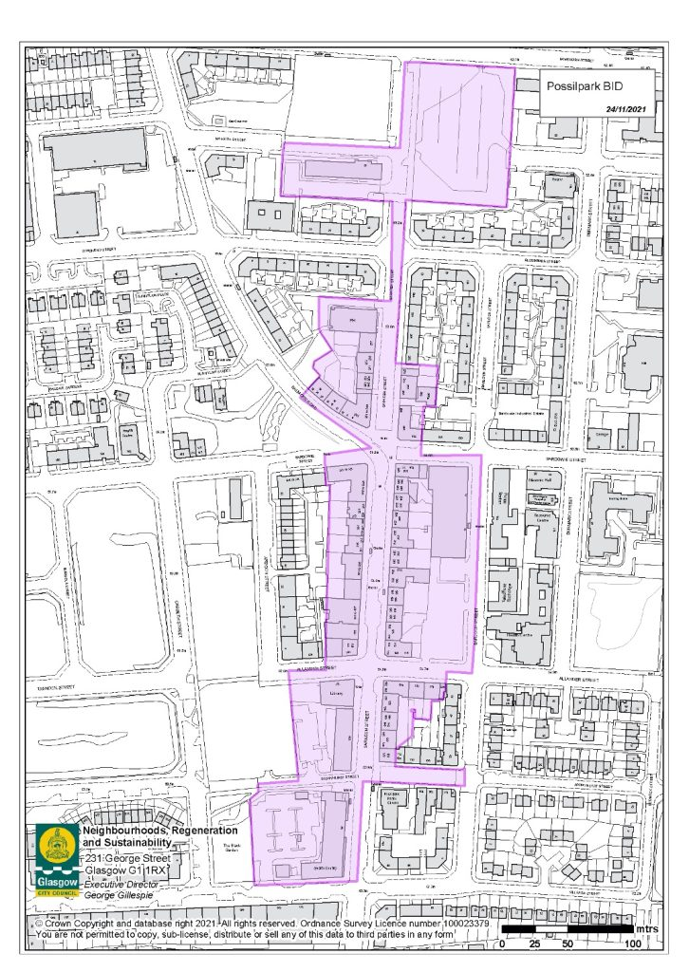

Case studies
The aim of the case studies is to show how similar organisations operate and achieve financial sustainability.
Adventure Play: The first example operates as a simple, largely volunteer run project in public parks; the second is a very high profile project for children with disabilities; the third a project within a successful West Lothian organisation. All have lessons for Concrete Garden’s adventure play development. They also show how other Councils handle land tenure.
ROAM
This Birmingham based CIO (charitable incorporated organisation) was set up by 2 mums (one a community architect, the other a PS teacher) who wanted to see children have the same freedom to play freely outdoors as previous generations. ROAM was set up with the aim of facilitating children’s freedom to explore nature with minimal supervision.
The model they have developed offers a range of play sessions, depending on the child’s age, ability and confidence:
- ROAM Free are sessions offering self-directed play in nature in groups. Sessions are held in a public park, and start off from Base. Children are briefed, given three golden rules, and left to play, with a team of volunteers discretely keep tabs of the children’s whereabouts, whilst not intruding in their play. Sessions last around 1.5 to 2 hours. Parents or carers must remain on site at all times and can volunteer, enjoy some free time or take younger children to Rocking ROAM sessions.
There is no minimum age but guidance is provided to parents on deciding if their child is ready. New children can be matched with more experienced buddies to help them settle in.
- Rocking ROAM sessions are targeted at children who are not ready to freely roam, as a first step to developing independent decision-making and collaborative play in nature. Sessions are supervised but children are encouraged to explore freely, growing confidence in their own judgements, and to help each other out rather than relying on adults. The sessions also include structured adult-led activities, such as scavenger hunts and storytelling. Whilst most participants are aged five and under, some older children with additional needs have found these sessions appropriate for them for longer.
- ROAM-IN is their model designed alongside families for children with additional needs and their siblings. Whilst similar to ROAM Free, ROAM-IN is designed for children who need a little more support, a little more adult presence and a little more structure.
- ROAM in Schools are sessions in partnership with schools, held during the school day to suit the needs of the participating children. Sessions work best with mixed ages, and ideally in groups of eight to twelve. The sessions are similar to the Free Roamers model, but usually last an hour, delivered weekly for an agreed period.
- ROAM Outdoor Playgroups were set up directly in response to the disproportionate impact felt by many families of young children during the Covid lockdowns. The sessions provide all the variety of a playgroup in a secure parkland setting, with opportunities for outdoor play and a chance to meet other parents, ensuring that both children and their carers benefit from the fresh air and social connections.
They operate with a small staff team (all very part-time) consisting of the two founders in the roles of Strategic Director and Operations Director, plus 2 Session Leaders, both qualified Forest School leaders and experienced play practitioners. For everything else they rely on an enthusiastic band of volunteers.
Figures for the financial year ending 31 March 2021 show:
- Total income: £48,716, almost all grant funding which means that the majority of sessions were free to access
- Total expenditure: £25,776 – including staff costs £17,826; equipment & consumables £2,119; marketing and fundraising £2,677
- Costs are low because they rely heavily on volunteers for sessions to run, and instead of paying to use the park, they pick litter in the park for an hour on the day of each session.
As part of its sustainability planning, ROAM put some income generating strategies in place to reduce the constant pressure of securing external funding to keep sessions running. These included:
- Voluntary session payments, put in place in early 2021 as part of this sustainability planning. These payments are voluntary, ensuring that finances are not a barrier to anyone’s participation.
- It intends to try to generate income through consultancy and commissions for organisations like nature charities, local authorities or nursery chains.
- Merchandising (tee shirts, hoodies, tote bags and pin badges) provides a limited opportunity for raising some modest unrestricted funds for the business, as well as using the logo to spread the message and attract interest in the charity
https://www.roam.org.uk/sessions/
The Yard
The Yard has been supporting disabled children and young people aged 0-25 through adventure play since 1986, offering creative and inclusive play experiences in a well-supported environment, with wraparound support for the whole family.
Their flagship centre in Edinburgh was refurbished by BBC's DIY SOS Big Build in 2012, followed by the opening of The Yard Dundee in 2015 and The Yard Fife in 2016. They are now looking at expanding into the West of Scotland.
They offer a varied programme of drop-in, respite and transition youth clubs, early years, specialist sessions with schools, family play sessions, and inclusive play and disability training with child-led free play at the heart of everything.
For young adults who have grown up as members of The Yard, the 18-25s club at The Yard in Edinburgh, every second Thursday from 5.30 to 7.30pm, is an ideal way of supporting them to transition into adulthood.
The Yard Edinburgh is open for drop-in family play sessions every day except Sunday during the school holidays, with early years sessions, schools’ sessions and respite youth clubs, by advance booking only (not drop-in).
The Yard Dundee, in shared premises at Rainbow House, is open to members for drop-in family play sessions every Sunday (all year round). It is a PEF Framework provider so all schools in Perth and Kinross, Angus and Dundee can book term-time play sessions there.
The Yard Fife, in shared premises at the Argos centre, Kirkcaldy, has drop-in family play sessions every Saturday and Sunday all year round.
Financial sustainability: The largest sources of income are the City of Edinburgh Council, The Scottish Government, National Lottery Community Fund, The Christina Mary Hendrie Charitable Trust, The Robertson Trust, Walter Scott & Partners and BBC Children in Need. Substantial funding was also provided by a wide variety of trusts, foundations, corporates and local groups in the community.
Accounts for the year to 30th June 2021 show that most of the £1.6m income comes from grants, some donations and fundraising with only small amounts of income generated directly from activities - £25,365 from subscriptions; £3,900 from memberships; £5,434 from play sessions; and £1,600 of training income. They are looking at families purchasing services directly through personal self-directed support budgets which would increase income.
Partnership is key to funding and operational success with strong partnerships with Edinburgh City Council and with Dundee. The Edinburgh site is leased from City of Edinburgh Council for a peppercorn rent, with the lease expiring on 11th November 2031. In Dundee they are seeking a national corporate partner to build the new centre planned for Dundee on land gifted by Dundee Council. Initial talks with a construction company, keen to demonstrate their community benefit, are going well.
Glasgow development – They have been working for some time with Glasgow Council to take ownership and operate Linn Park Adventure Centre for children with ASN, currently managed by Glasgow Life. https://www.glasgowlife.org.uk/communities/venues/linn-park-adventure-playground
Their Membership structure might be of interest to Concrete Garden. Formal membership under their Articles is open to anyone over 16 who shares their objectives. At 30th June 2021 they had 39 members.
In addition to formal Membership of the Company, they also have two types of subscriptions for users:
- Young Adventurers are regular users of The Yard who pay £5 per month and have unlimited access to the family sessions and clubs. At 30th June 2021 there were 371 Young Adventurers.
- 38 families hold Visiting Membership cards; these are occasional users who have a time-limited membership allowing access for a specific number of visits.
https://www.theyardscotland.org.uk/
The Range Adventure Playground, Broxburn
The Range is a purpose built adventure playground in Broxburn which offers a variety of clubs and activities to all ages of primary school children. https://www.facebook.com/therangeplayground/
The Range is constructed on ground that is leased on an annual lease that will continue to run under tacit relocation (Scots law term meaning the contract of lease will automatically repeat unless one of the parties signals that they do not want this to happen). This arrangement has operated well for a number of years and the belief is that neither party is likely to formally terminate it.
The Range run outdoor after school Play Clubs for primary age children and a programme of activities during the Easter and summer holidays. They charge £10 per month or £40 per term for all clubs, payable on registration/by direct debit.
The Range is one of the activities of Family and Community Development West Lothian (FCDWL), now known as Play Works. It generates £138,000 in out of school care fees. Its subsidiary charity, Simple Play runs ASCs and generates considerably more.
They are currently advertising for a Community Playworker for the Range at £10.50 per hour.
This final case study focuses on tree planting and might be of interest for development of the new play space as trees and climbing are high on the young people’s list of priorities. Their learning chimes with Concrete Garden’s own experience:
Trees for Cities
This is a London based charity (registered charity no: 1032154) operating nationally (mainly England although with some limited planting projects in Scotland) which has been transforming urban green spaces for almost 30 years. It has played a key role in pioneering urban environmentalism and bringing to the forefront the massive role that trees and green places play in the health and wellbeing of communities and in providing life supporting ecosystem services.
Their strategic plan includes the following learning which will resonate with Concrete Garden’s own experience:
- The demand from children and youth to be stakeholders in the future of the planet is loud and needs to be met. Young people need to continue to be given the educational opportunities to be immersed in nature and to gain from the lifelong benefits it brings. They need the mechanisms to turn their energy into action.
- Sustainability and social responsibility has risen up the business agenda at remarkable rates over these recent years. This presents opportunities, but also challenges. Whilst harnessing the potential could be transformational, the risk of working with the wrong business in the wrong way has increased proportionately. It is important that the efforts of the business community are pointing and pointed in the same – most impactful – direction.
- The private sector has enormous potential to help drive transformational change. They not only have massive resources and skills to contribute, but workforces that are ever keener to take direct action and influence corporate strategy, as well as customers that want to buy from ethical providers. The proliferation of sustainability, CSR and ESG agendas is extremely positive, but the urban environment needs to be mainstreamed into these approaches and better coordination is needed across the business community to ensure that the impact is greater than the sum of the parts. There is a risk that, while businesses are under such scrutiny to charge towards net zero and show their green credentials, either their funding choices are not optimised or a new wave of greenwashing could arise.
- A proliferation of central and local government policy has developed of late, but there remains a gulf between policy and delivery plans. The ‘how to’ now needs the most focus of all: the delivery plans that will turn words into action.
Although their focus is on planting trees, they have also worked with a number of schools to develop edible playgrounds, transforming school grounds into greener and healthier places through innovative design, high-quality planting and landscaping, and inclusive engagement of the school community.
Financial sustainability - They are funded from a mix of grants but with significant income from donations and work with corporates. The aim is to access funding streams linked to payments for nature-based solutions and ecosystem services i.e. potential for tree planting as part of carbon offsetting.
https://www.treesforcities.org/

5. Community Consultation
Community consultation is always a priority for all of Concrete Garden’s activities to make sure that all plans and proposals meet the needs of the local community and have community buy in. For the proposed acquisition, it is important not only to steer the development but as evidence for the asset transfer request and funding applications.

Previous consultation work
An eight week participatory action research project in 2019 focused on defining a vision and mission statement for the community garden. Consultation evidence included the following:
Focus groups with children age 6-11 identified:
- Recurring themes included friendship, happiness, playing and learning. The children mentioned being happy in the garden, and making friends in an inclusive environment.
- Playing and being able to play freely seemed to be very important for the children.
- Children also learn in the garden - about gardening, games and also how to play with children from different backgrounds and ages. Learning in general and learning about gardening was talked about more loosely, and it did not appear as the children’s priority when they entered the Back Garden.
For adults recurring themes included wellbeing, connections, and confidence.
- In terms of wellbeing, people were confident in saying that they felt better physically and mentally. Reduced anxiety was mentioned repeatedly. People talked about the gardens’ beauty, how gardening was an enjoyable activity in a nice environment, and how it had made them eat more organic fresh vegetables for free.
- On connections, there was an emphasis on how welcoming everyone is and how lovely it is to share knowledge and experience. The garden fosters social connections. Volunteers and participants mentioned how it provided a safe space for people from different backgrounds and ethnicities to get to know each other.
- This prompted conversations about increasing confidence, having a sense of purpose and something to look forward to.
- People emphasised how important it is to educate children about the environment, and for them to develop a connection with nature.
Looking forward, both staff members and adult focus group participants mentioned
- Expanding the garden’s reach and having more gardening sessions and gardening sessions at the weekend
- Having more community socials and community events
- Hosting additional training and qualifications, which would allow volunteers to run workshop sessions
In terms of physical infrastructure development, people suggested more sitting places, another polytunnel, more wildflowers, a small pond, and a birdhouse.
Volunteers discussed selling some of the garden produce e.g. vegetables and jam, partly to raise awareness of the Back Garden and its purpose among people living in Possilpark, and partly to contribute to sustainability.
Children worked on their Dream Garden, where they wanted something to slide on, something to climb on, and something with water, and to have more food provided in the Back Garden.
Through community consultation, observations and local knowledge, staff have identified the following needs:
- Cornerstone services that remove the barriers to participation in outdoor life, and opportunities that improve their health and well-being for marginalised and under-represented groups
- Opportunities for everyone to become involved in the social, and cultural outdoor life of Possilpark
- More outdoor places and activities that support integration
- Flexible and meaningful outdoor employment, volunteering opportunities and training.

Consultation work undertaken
Consultation included:
- Informal focus groups with Back Garden users and with the young people in the play area
- Surveys using SurveyMonkey, one for the Back Garden growing space activities and one specifically for young people and play area users
- Attendance at local events to gather informal feedback
- Stakeholder interviews
- Use of social media to gather opinions

Feedback from events and conversations
The consultation comments that follow were gathered at visits to two Back Garden sessions, two play sessions and two well-attended events - a Family Open Day and the Harvest event.
All those spoken to are hugely appreciative of the current activities and fully supportive of the proposal to acquire and develop the land.
Back Garden
I’d be lost without the Back Garden; I’ve been coming here for 6 years.
I started by coming here to play and got introduced to a plot which started me off on growing and eating new veg.
I love vegetables when I’ve grown them myself – they have a different taste.
It encourages me to eat more veg because I’ve grown it myself.
The Back Garden gave me a reason to come out of the house when I retired. I enjoy growing my own veg but I also love the companionship.
I used to come along occasionally; now I come weekly and I really look forward to it.
My grandkids came along here before I did. They enjoyed planting, watering and seeing things grow.
If we had a little shop or stall, we could sell plants or produce to bring in some money. People would buy them as they have a different taste from Lidl’s.
We often get asked to help others to set up community gardens or help with theirs. This is too time consuming for staff but creating a ‘Garden rescue team’ could be a great volunteer opportunity, as well as a way of generating some income.
We’d like to develop more of a wildflower meadow and sow more wildflower seeds. The area we have attracts bees but we could do more. It would encourage more butterflies, bees, etc with opportunities to monitor wildlife – for adults as well as children. Why shouldn’t we have more wildlife in Possil?
Kids love coming here with teachers and to the wee gardening club.
Growing your own food is great for your wellbeing – mental and physical.
People are starting to come back after Covid. Word of mouth brings people in.
A lot of people locally are not really that aware of the Back Garden. They need to come in and see what happens here. They’d want to come back. I know I do.
At the moment we are oversubscribed so some people have a quarter plot. It would be good to have more plots available for more people.
I live in the community and am in recovery. As part of that, I have to make a 16 hour commitment. Options include Lambhill Stables, recovery cafes (lots in Glasgow) and support through Elevate, as well as the Back Garden. I started coming here and love it because it is friendly, a safe environment and no pressure. In our plot we have grown veg which we have harvested and shared, and sunflowers for Ukraine (the recovery community are doing this). I like the peace and quiet and the fact that there is always a job to do but no pressure, which is really important. Everyone mucks in and I have met lots of people from the area and feel like part of the community again. I’m getting my life back on track. I think it’s fantastic to be able to buy the land.
I suffer from acute anxiety. For a while I was very bad, on the point of suicide. Finding the Back Garden has really helped me. It’s better than any prescription from the doctor. The fact that I come along here to actually do something makes the difference. It occupies my head as well as my hands. I wouldn’t get up and go somewhere just for a cup of tea and a blether.
It’s a much more diverse community and people eat a wider variety of fruit and veg. We can learn from one another, particularly those from other cultures.
We are new to the area and came along today for a look. We’re just so impressed by what’s happening here and really want to be part of it.
It’s very welcoming and therapeutic, which is a benefit for the individual and also for us as a peer group.
I came in here when I moved to the area and became a volunteer. I loved coming here. I’ve since moved away but come back to catch up with people. I haven’t found anything similar to the Back Garden in my new area.
Volunteering leads on to other opportunities, both in the garden and with other groups. That builds up confidence and transferable skills which lead on to employment or further training. That’s important in an area of high SIMD deprivation.
It’s great that families can come in together. One day I watched a young boy in here with his family. He was looking round the beds and he could identify all of the things growing there. That’s impressive!
I’ve taken what I’ve learned here and now make use of my own back garden to grow a whole range of veg that I would never have thought of trying to grow. I can always get advice and tips to help me.
We could have some stalls every few weeks to sell produce to local people. We could also link to the food banks and provide them with surplus produce.
We want more gardening classes for young people, not just for adults.
Councillors and MSPs should be queuing up to help secure the land.
Funders need to come and see just how amazing this is.
We live in an upstairs flat so coming here is great for me and my kids. It’s such a welcoming space for everyone.
I think it’s brilliant here – the best thing ever!
I’ve lived in this area for a long time. Some of the area has changed with the new building but other bits not so much. This used to be an ash covered space so it’s good to see it being put to good use.
Losing the Back Garden would be bad for us all. We need to keep it.
Play area – (mixture of comments from families and young people at events)
I never went out before I started to come here. Now I’ve met new people. I like the people who lead the sessions – they taught me to make a fire and we have made pizzas. I made an animal hotel for our garden.
My daughter was suffering badly with depression. There’s not much help out there and it has been difficult as a family. Coming along to the play area has really helped.
We came here from Sudan 2 years ago so lockdown made it hard to get to know people. I like bringing my kids to the play sessions. They enjoy being with their friends and I can talk to other mums. I’m getting better and more confident at speaking English.
We definitely need more space to play as other play areas have gone and there are no play parks. Kids need to be able to get out and play.
The Back Garden play space can stay and serve its original function which was as a space for young children to play safely while their parents, etc worked in the garden. The new play space will give children more room to play freely and not have to worry about damaging anything in the garden. They are very good but it would be great if they didn’t have to think about being careful. They can of course still come and help with garden if they want.
It would be great to see the play area in a new space. Having a safe space to play and run about in is good for health and wellbeing.
The new play area would give the kids space and freedom to run about and not have to be careful, as they have to be in the garden.
It is good as it is but we would love to enlarge the play area with more opportunities for learning and education.
We can leave a green area around the play area for people to use and walk through.
Having the other field as a play space would be a big bonus for the kids.
The kids should be left to design the play space by themselves.
The play area needs to be safe and at least partially enclosed. It would be good to make use of natural materials. Anything in an open space would have to be sturdy.
Ideas for the play space – a mud kitchen; tree house; watch fires; an outdoor cinema projected onto the big wall at the bottom.
The need to retain as a green space
They are building everywhere so we need more places like this. Why shouldn’t Possilpark have quality greenspace?
Nothing has happened on the other site for 20 years. Using it as a play area would be good.
Developing more housing is good for the area but more houses put pressure on existing infrastructure, schools and amenities. Development has to be carefully managed so that the area retains its sense of community and doesn’t just become somewhere where people sleep. Developers don’t always seem to remember that.
Instead of building more new houses, they could renovate more of the existing housing stock.
We need more open green space in the area – not it all built on.
The (proposed play area) land is just sitting there, doing nothing. We can’t let it just go to ruin.
A lot of people have been in the area for a long time. People tend to like the area and want to stay. The houses across from the Back Garden were all privately owned at one time and people took pride in keeping them nice. The new housing is bringing in more diverse tenants but that’s no bad thing.
It used to be a really vibrant community with lots of families up each close. It’s changing but we need to keep that vibrancy and sense of community and bring in the new people.
This area needs the Back Garden and the Concrete Garden in among all the buildings. We need to keep green spaces like this, especially when they work so well.
The Canal is nice for a walk but it would be good to link up green spaces.
We lost our nature trail when the bit of land was sold by GCC. It had frogs, birds and deer.
Claypits is not the most accessible.
Saracen Cross is a mess. They didn’t think long term. They spent money redeveloping it but put in things that need maintenance without anyone responsible for maintaining it. The kids have to sweep up the glass to use the Parkour.
The Keppoch/Hawthorne multi-school campus was controversial but has worked well – 9 out of 10 of the young girls are moving on to college or university which is great to see; the boys are less inclined towards college as they are keener to get out and make a living. It’s not a bad area for kids but the playground amenities are not large enough.
It’s rumoured that Young Possil Futures and Possobilities are both struggling for funding which would be a big loss for families. We can’t afford to lose the Back Garden and the play area.
We would be part of a green corridor leading to Millennium Square.
The area is being built up so we need to keep space for the kids to play.
We have never had any serious vandalism at the Back Garden. March, April, May is always ‘mad season’ with some small incidents but the kids generally take ownership so take care of the site.
The planned new housing (623 new houses, 25% ‘affordable’ – but not for ordinary folk) doesn’t include any new play areas. The new housing near the St Matthew’s Centre is like a gated community – they don’t spend their money or leisure time in the area.
Even the schools have been closed. We had 3 schools with swimming pools. Now the HS kids have to get 2 buses to get to schools outwith the area.
They are trying to get a new community centre at Possilpoint and, although the planning application is in, they are facing lots of barriers. See https://www.collectivearchitecture.com/projects/possilpoint for design
Everyone needs green space; it’s good for the environment and for wellbeing. Possil needs green space.
How owning the land will help
Security of tenure is essential for use as a community project. We need that guarantee that we can’t be thrown off.
If we lost this space, it would be hard to find another suitable piece of land in the area.
It would be empowering to own the space and let people have a real say in developing both spaces.
It’s definitely a good idea to buy the land. I know some people think the field could be used for housing but we have plenty of houses and need to protect the green space.
The Back Garden site looks too small for housing development. Who else would want to buy it?
If we own the site, we can set it up as we want. We can also start to fundraise from people as well as from grants.
We can secure funding to improve accessibility e.g. fully accessible Portaloo, baby changing facilities, ramps and beds that are the right height for wheelchair access.

Staff comments
Back Garden Impact
Regulars tell us how much they value this space and being able to come here.
We can see the increase in self-confidence and people taking on a level of autonomy as they get comfortable giving feedback and sharing ideas and opinions.
There is a real sense of connection between participants; some already know one another but a lot have met for the first time here. You see them checking in and making sure that everyone is OK.
Participants seem to enjoy all of the activities. One of the comments we hear is that they would like more regular access to the garden, rather than being restricted to session times.
Some of the participants have mental health challenges so being outside, active and having social contact really makes a difference in terms of managing their mental health.
It would be good if we could hold more events, especially those bringing volunteers from both the Back Garden and the Concrete Garden together. Some volunteers do both but mostly it is different attendees.
Our Volunteer Action Day showed that half were keen to continue tasks that they were doing pre-Covid. The challenge is finding staff time to organise this.
Redesign
A lot of the existing structures are beyond the end of their lifespan. We have a Permaculture Working Group that is working on the restructure which would see a ‘redesign and replace’. Attendees and the staff team have learned what works well, and what doesn’t, so we know how to make it better.
We did a learning exchange to see other sites and get ideas for ours.
A family new to the area have recently engaged with this group and are keen to be involved. This brings in a new set of eyes and some fresh thinking, which is really valuable.
If we own the land, we will be more appealing to funders which will allow us to access funds to improve the infrastructure in relation to utilities and water and create a better cooking space.

Back Garden survey responses
This survey was available online with the link shared through Concrete Garden’s social media, and in paper format at the Back Garden sessions and events.
44 people completed the survey, mainly from the immediate area but some visiting the Back Garden from other areas for the events - 27 live in G22; 3 in G20 and 2 in G21; the others came from a wide range of postcodes (G4, G11, G33, G41, G42, G53, G65, ML6, PA2) although many have family connections to the area:
- G65 but my gran lived in this area and I grew up in G21
- G31 but my daughter works in the Health Centre here. That's how I found the Back Garden.
Of these 55% are regular visitors, 27% are occasional visitors and the other 18% were first time visitors who had come along to one of the open events.
People were clear about what they would like to see more of in Possilpark:
More green space 86% 38
More opportunities for meeting people and meaningful social interaction 84% 37
More opportunities for learning and education 80% 35
More opportunities for re-use and waste reduction 70% 31
More social space 66% 29
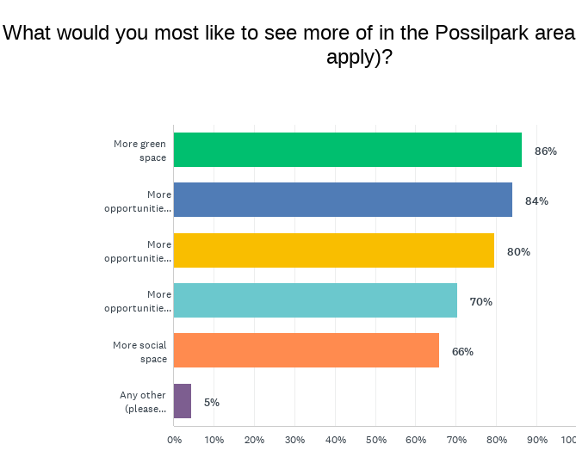
Any other (please specify)
- More for disabled people - better accessibility, etc.
- More safe outdoor spaces for kids to play in

There was unanimous agreement that the Concrete Garden should acquire and develop the Back Garden site as a community growing space.
Respondents gave us a big list of reasons showing why they think this is a good idea:
- More benefits - (1) mental health; (2) social interaction; (3) education; (4) environment; (5) nutritional - ingredients, recipes, health benefits
- To help educate and integrate with the local community.
- In this time when flats and houses are going up everywhere, this Back Garden is so important.
- The play area is also a much needed space for our children.
- This is a great initiative.
- It's a good place for learning things.
- The Concrete Garden has made such a positive impact on the lives of many. Therefore, to develop and progress, the people of the community deserve the area to be used for various events and activities bringing lots of different cultures and the whole community together.
- I came today with a friend to the Harvest celebration and love what I see.
- The land was lying not used for years so it’s good to see it being put to such good use.
- This is a great space for kids and adults to learn, have fun and have a great experience. I really like to have the opportunity to grow and eat my own food. The Garden Club is great for socialising and being creative.

- To develop a greenery and also family can engage to grow plants. Personally I feel very proud as I have got an opportunity to have a plot where I grow some herbs; when it’s ready to eat I feel so overwhelmed. I know the plots are in high demand but, if I can get more plot, maybe I can grow so many vegetables and teach my kids also about how to grow plant in practically. The wee playground also very eco-friendly where kids can enjoy so much. So definitely this garden should develop as a community growing place.
- It’s important to secure the future of the site.
- To protect this important social green space from becoming more housing!
- If the Concrete Garden acquires and develops the Back Garden, our whole community would benefit. The new construction in Hamiltonhill is severely limiting green and play spaces and our kids need places outdoors to be kids. Adults need places to be together and to know they can contribute and make something. Both kids and adults need to be in nature and away from screens. Developing the Back Garden would only have positive mental health outcomes for everyone who would use the space and that would have knock-on effects for the entire community.
- It is great for bringing the community together.
- It would allow them to further develop the land and give permanence. It would recognise the work and investment in the space that has already been made. It would give stability and increase the community’s access to fresh fruit and vegetables.
- The team is working hard to keep the garden as a very good place for the kids; however we would love to make more opportunities for learning and education e.g. how important the green space is and reducing waste.
- So that the community has more say in our community spaces.
- Possilpark needs more community meeting places so everyone can get to know one another.
- This place is better than any doctor's prescription.
- This will help secure it for the future use by community.

There was also very strong agreement on the various ways that acquiring the Back Garden as a community owned growing space will benefit the community:
It would retain a much needed green space 100% (44 people) agree
It would let people have a plot for growing 100% (44) agree
It would be good for the environment 100% (44) agree
It would bring the community together 100% (44) agree
It would help local people learn new skills 100% (44) agree
It would help people feel less isolated and more useful 100% (44) agree
It would give people access to healthy fresh produce 98% (43) agree 2% ‘don’t know’
It would create volunteering opportunities 98% (43) agree 2% ‘don’t know’
It would give more opportunity for social interaction 98% (43) agree 2% ‘don’t know’
People also mentioned the following other benefits:
- It is somewhere beautiful, good for people's mental health, accessible for those on a low income, somewhere for the kids to play and a place to learn new skills.
- It is a great area to relax in and play. It allows a great view from nearby flats. It allows people to have a garden space within the city.
- It also gives an opportunity to grow your favourite vegetables and be close to nature.
- As a learning environment for children
- It would be a free space open to all. These types of places are rare.
- More personal contact with strangers
Respondents were also very clear about the huge negative impact on the community if Concrete Garden loses the Back Garden:
- It would be a loss for all the people who come along. Without the Back Garden, a lot of them wouldn't get out of the house.
- Losing the Back Garden would be a great loss to the community and the health and wellbeing of the communities.
- It would be devastating for the community. No fresh veg or fruit so some people would starve which I don't agree with.
- It will lose all of the benefits listed above that come from the growing space and a social environment where people can interact
- Locals and kids would lose a community place for positive interaction.
- It would be a massive loss to the community.
- Big loss to the community
- Children need fresh air and to be occupied. They love helping and seeing things grow.
- A lot of people will be sad.
- Loss of social interaction as there are few other local opportunities for social interaction. It is also good for children and helps kids to learn new skills.
- It would be a significant loss for the Possil area
- It's a small oasis in the middle of a very busy, quite dense area.
- It would affect all the people involved; they would all be lost, depressed and in a bad place.
- The Back Garden is one of the few community spaces in Possil, one of the few green spaces and the only growing space. The space is an important asset which brings the community together. It also provides childcare for the area 3 evenings a week.
- Losing the Back Garden would be devastating for the whole community.
- The community would lose a safe space to come together and share and learn new skills.
- Loss of social interaction
- We would lose one of the most valuable spaces in the north of Glasgow.
- We would lose the joy it brings. Lose all the opportunities for healthy food and play space.
- The Hamiltonhill area of Possilpark would lose a much valued green and social space and further increase the lack of resources around Possilpark.
- People wouldn’t have any access to a garden especially those who live in apartments and flats. More isolated, no social interaction and eventually it affects community people’s overall health status.
- We would lose all of the things we value.
- Families and children and vulnerable adults would lose one of the only safe green spaces in Possilpark.
- Isolation, loneliness, and antisocial behaviour would increase, sense of dignity and contribution would decrease. If the city council or any other investors actually value positive mental health, they will make sure the Back Garden remains open.
- It would stop all the different nationalities getting to know each other and feel welcomed in the community. The satisfaction of growing and eating our own produce. The Back Garden gives you an interest and reason to leave the house.
- We would lose a valuable green space and enjoyable area for kids.
- It would be a big loss for people in the area. Although I don't live in the immediate area, I like coming here and helping out. I like the people here.
- There would be no space for kids to play outside so they'll only be inside. All the good work that has been done would be lost.
- There would be no interaction for small children. It is best to keep the Back Garden.
- Kids would lose out. The Back Garden is doing great stuff with local kids.
- A very big loss; less chances of meeting with everyone.
- My daughter has been coming here for years. I would like to see it continue. The youth workers here are so helpful. This would be devastating to the local community. The back garden is a fantastic space for a big range of people from the young people who use it for play sessions to those who get involved in growing. I think it has a positive impact even for people who aren’t directly involved to see an area of land so well used and cared for when 100% of people in this community live within 250 metres of derelict land and endure the negative impact that it has.
- Less access to fresh produce, social interaction, abandoned land which could be an eyesore.
- For myself, a disaster.
- Major loss and really just another big setback for a community already suffering from lack of clean safe social outdoor spaces. We have had nothing but derelict, dirty and dangerous land left by landowners for over 20 years. The Back Garden just lifts the mood of the whole area. It’s a great space. Really welcoming and well used.
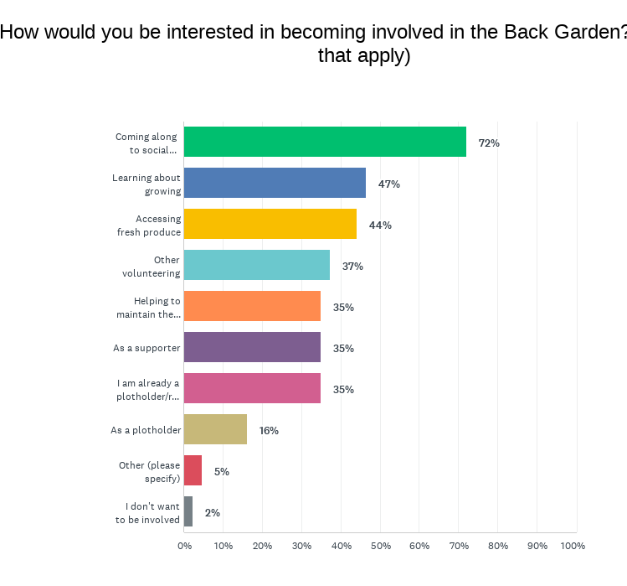

35% of respondents are already plot holders or regular users.
Others are keen to be involved in a number of ways:
72% want to come along to social events
47% want to learn about growing
35% are willing to help to maintain the garden
16% would like to become plot holders
44% would like access to fresh produce

37% are interested in other volunteering and 35% would like to be supporters.
One commented: I would love to have a bigger plot if possible. It’s very helpful to have places like this for people who live in apartments with no access to a garden.
14 people were interested in being part of a focus group; 4 in taking part in a 1:1 interview to discuss more fully; and 10 in some other way. 12 people left contact details which were passed on to Concrete Garden to get in touch.
People took the opportunity to leave these final comments and words of encouragement:
- Long live the Back Garden! In the new space, what about a community outdoor cinema in the sloped narrow bit at the bottom?
- It would be great to make the Back Garden more accessible. The paths are fine but it would be better with a ramp, a fully accessible toilet and some lower beds for people in wheelchairs.
- I love the Back Garden!!
- A big thanks to the people who work here.
- This is a great place for anyone with anxiety and depression. No pressure and plenty to do. Keeping busy occupies the head as well as the hands.
- Keep up the good work. Thanks
- Well done, guys!
- Good luck!
- Thank you, Concrete Garden.

Young people’s thoughts and ideas
These thoughts and pictures were gathered at play sessions to show what the young people like to do and want to have in the play area:
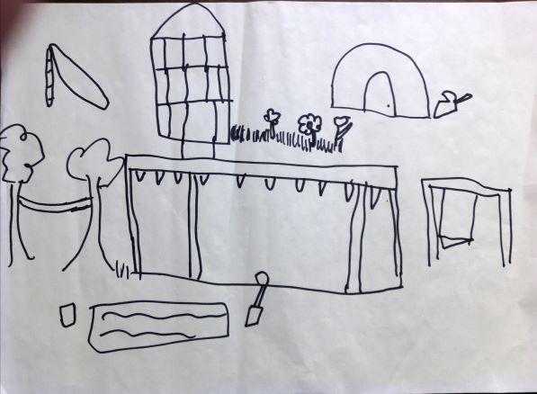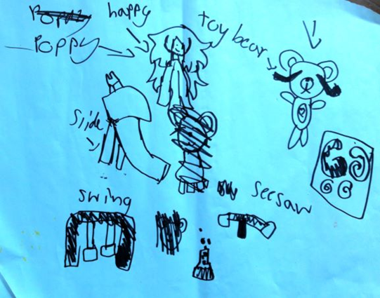
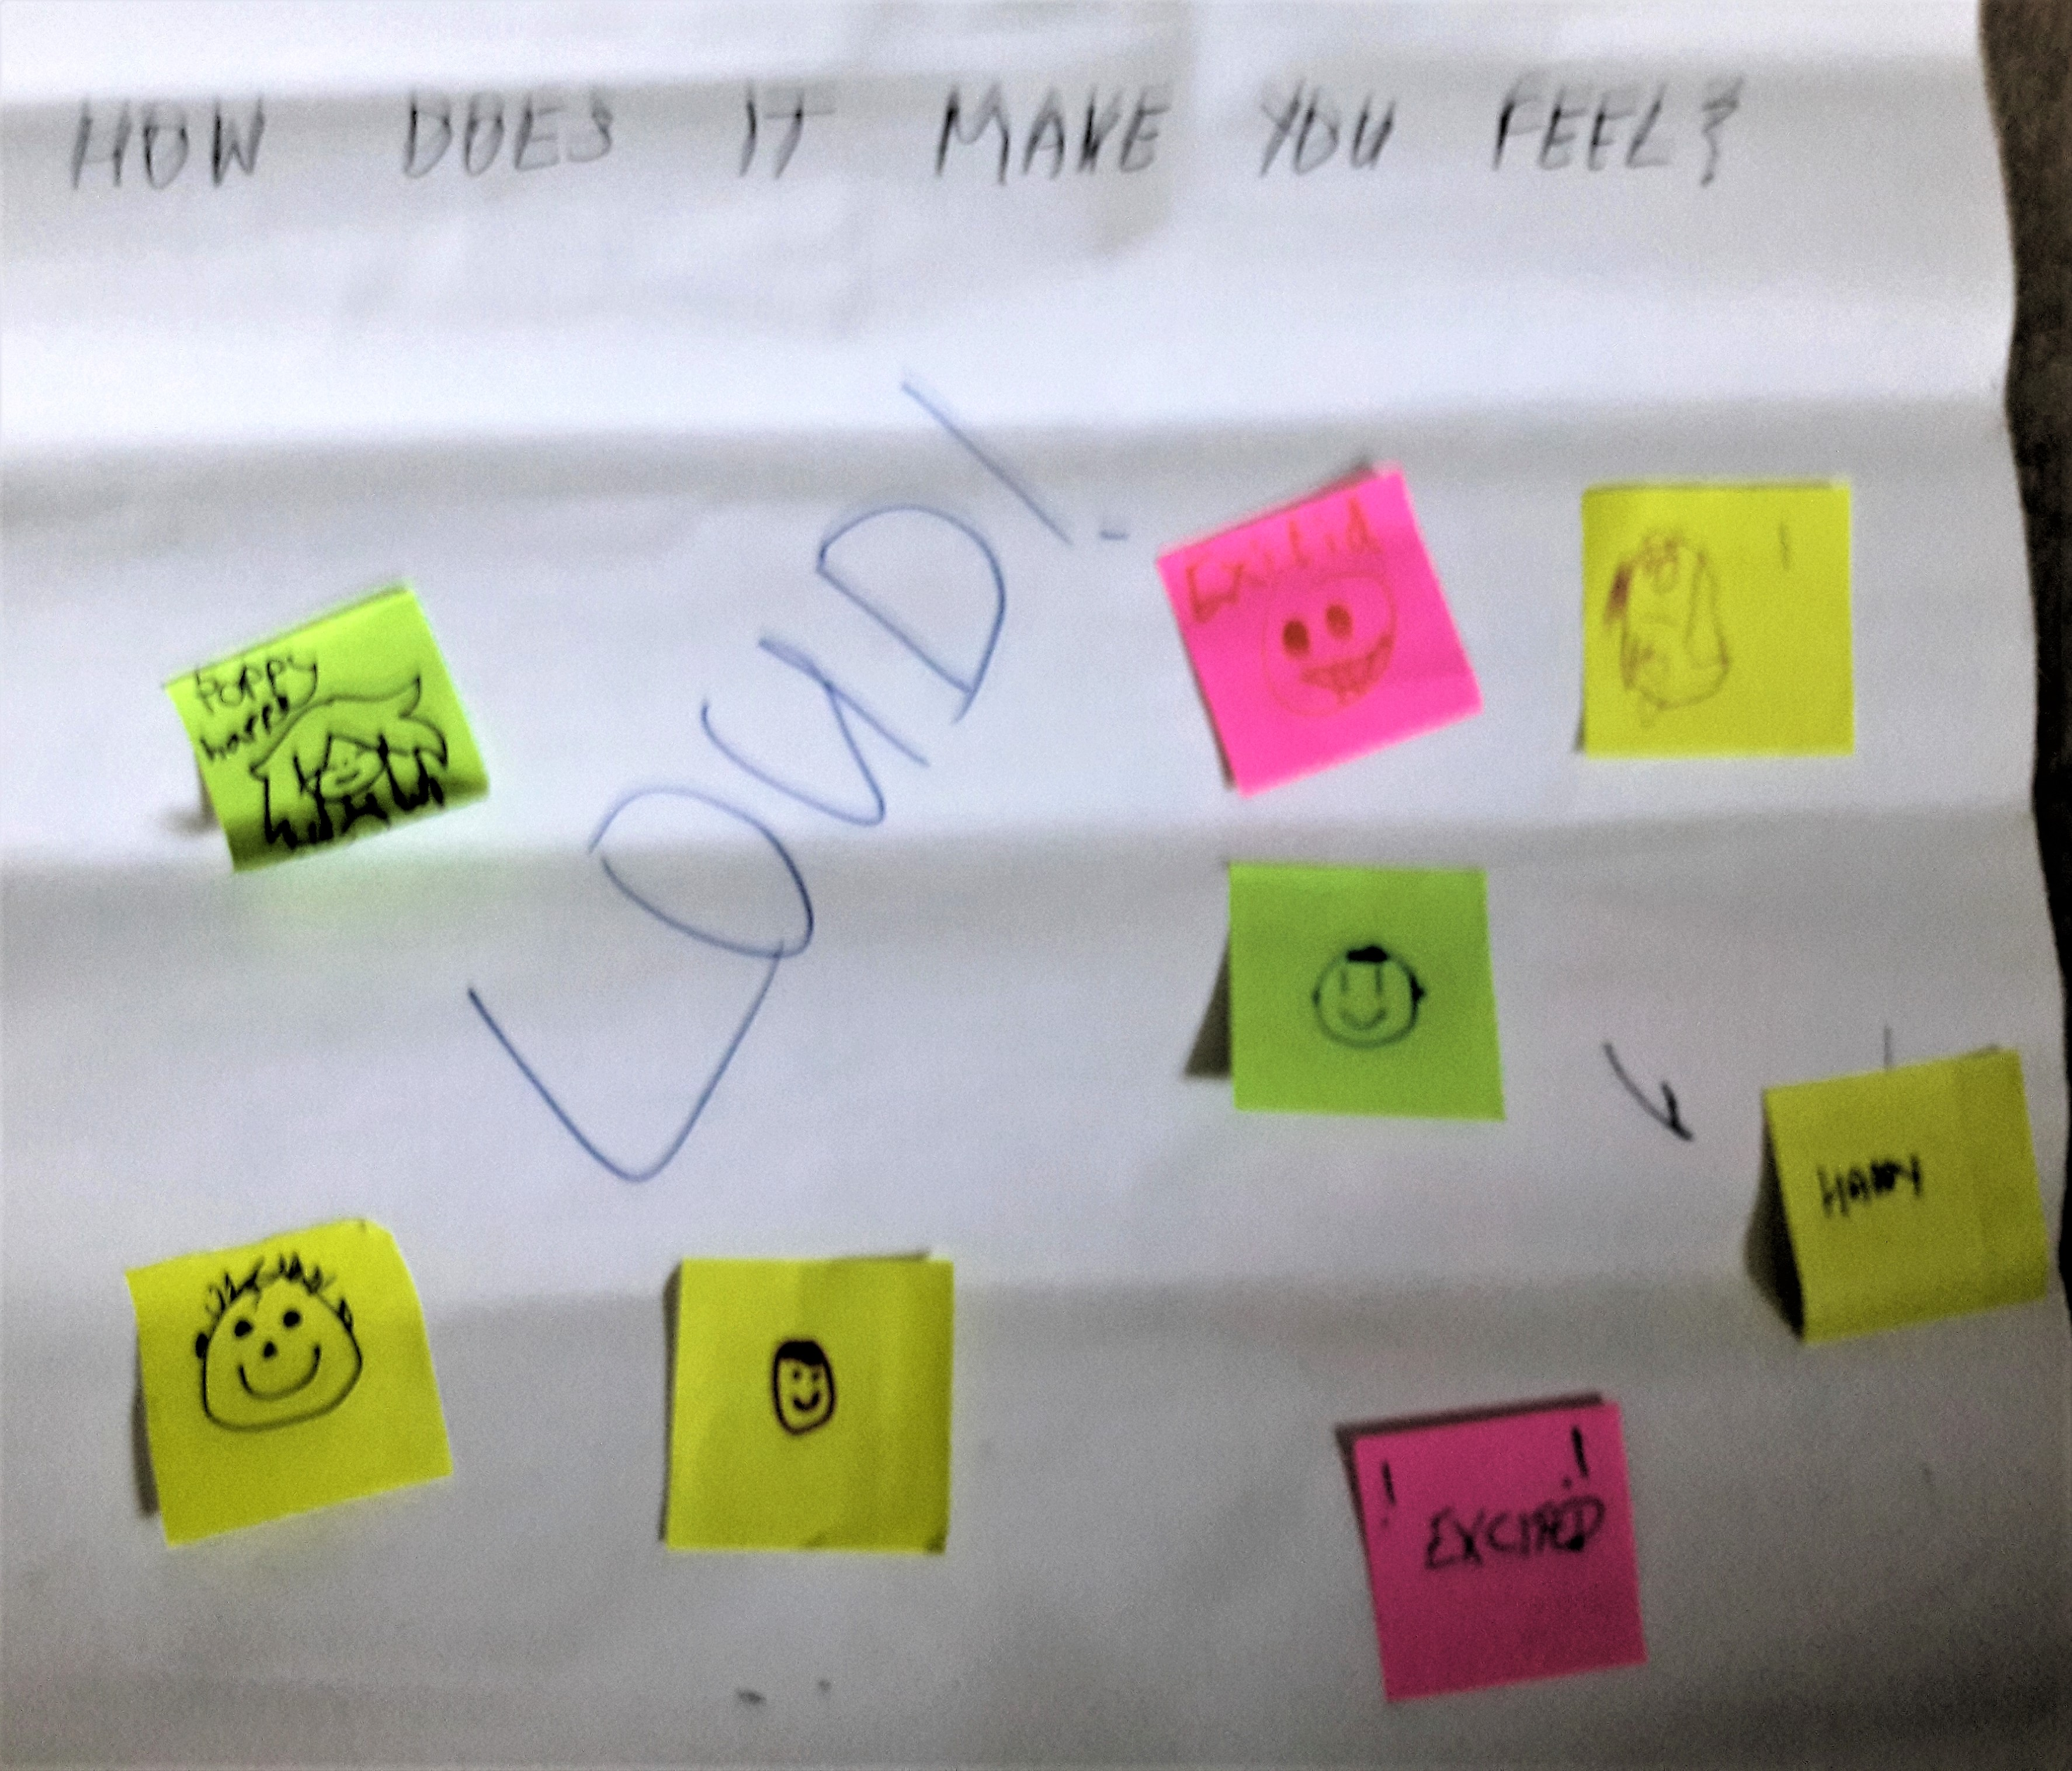
What do you like best about the play sessions?
- Running about
- Climbing
- Playing with water and soaking people
- Being with my friends
- Building dens
- Making things
- Getting to do what we want
How does coming here make you feel?
- Happy (said lots of times)
- Excited
- Good to be able to be loud

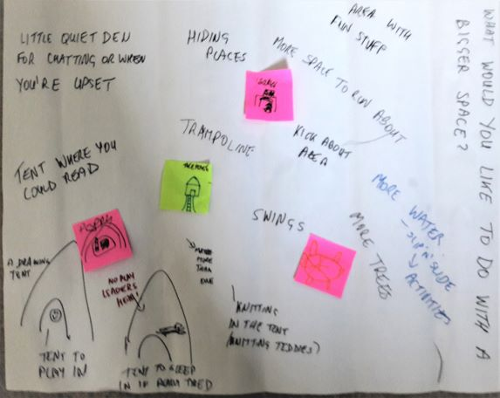
What would you like to do (more of) with a bigger space?
- More space to run about
- More water
- More slip’n’slide activities
- More trees
- Swings
- A treehouse (maybe more than one)
- Area with fun stuff
- A kick about area
- Area for bikes
- Hiding places
- Trampoline
- A little quiet den for chatting or when you’re upset
- A tent where you could read
- A tent to play in
- A drawing tent (so the paper doesn’t blow away)
- A tent for knitting; I’d knit teddies
- A tent to sleep in if you’re really tired (no play leaders allowed to sleep)
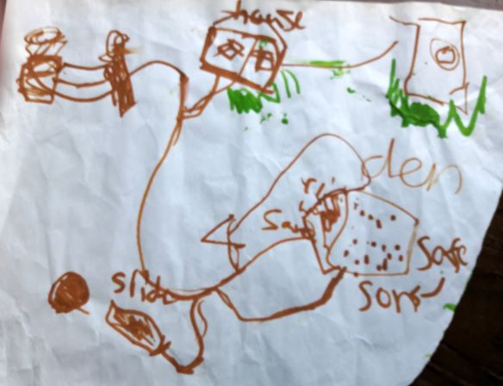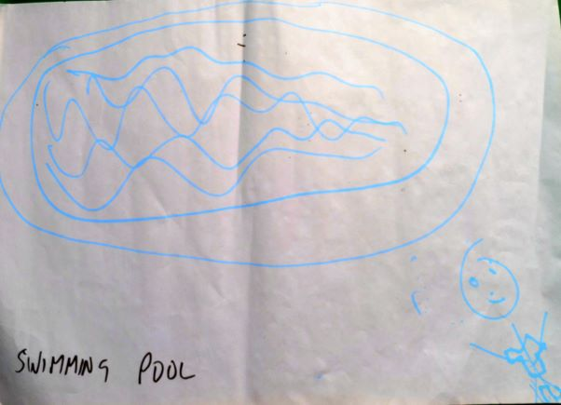
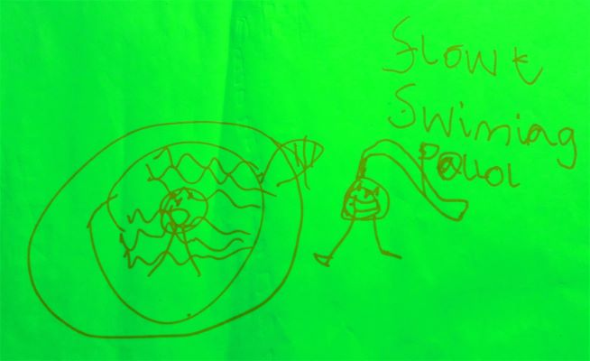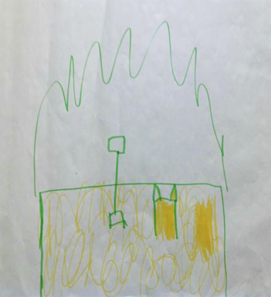

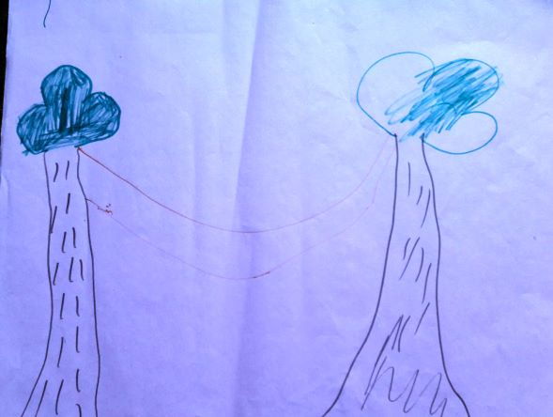
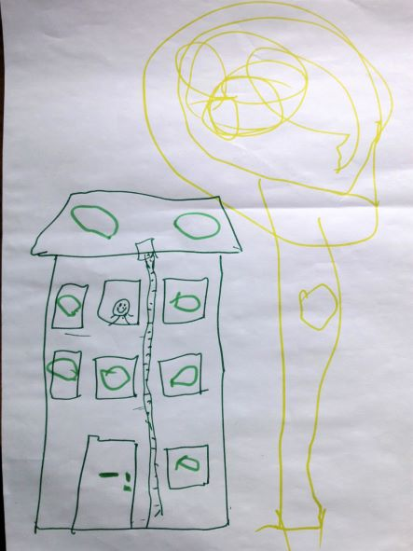

Play Team comments
The play team has a very specific approach to their work with the young people. Although based on free play, there is a high level of engagement and individual support from the play team. This, along with their knowledge of the community is why it works.
With a strong team of 7 who get what it’s all about, supplemented by 2 more new starts, the team now have time to look forward and think about the additional space. They agree that the Back Garden is an amazing place for the kids but limited by its size. The new space offers a lot of scope for what can be done there. The idea is exciting but also a big change in the size of the space so the consensus among the team is that the space needs to be developed gradually working with the young people and the community so that it responds to their needs. Development needs to be organic and within capacity to get it right.
The intention is to make use of the space now, initially on Thursdays, when other people are in the Back Garden. These sessions are showing how the young people take to the space and how they choose to play there. Play team staff are starting with no fixed ideas of what that will be, but observations and feedback from the young people will guide the development of the space. As a team, they recognise the changes that will come with managing the larger play space in terms of logistics, especially if there is more free play. The transitional use will help with learning. That said, it will great not to have to be too prescriptive about what the young people do.
In terms of use of space, what works in the Back Garden is that there are lots of little spaces, divided by willow fencing. This idea of areas and corners will work just as well in the bigger play space, with the young people deciding what goes where. Other ideas include:
- planting willow
- planting trees (central to a lot of play)
- a wild/nature area, as part of the environmental message, understanding of wildlife and nature, and for adventurous and creative play
- creating bike jumps in the accessible area, as well as space to cycle
- a kick-about space for football and other sports
- benches for other people to sit and chat
- In terms of play materials, starting with loads of tyres and pallets (easy to get hold of) to see how the young people want to use them – for dens, etc.
- Including a café, coffee space/kart, and an open air pop-up cinema have also all been mentioned.
Part of the area will need to be fenced off but it would be great if big parts could be accessible all the time as the young people often say there is no place for them to go and play. The team are aware of the fears of vandalism from the community but in the 5 years in the Back Garden (3 as a play project), vandalism has never really happened. Provided the community, including the young people, feels ownership of the site, they will keep it safe and nurture it, as they have done.
As well as more space for creative play, the new site will make play services more visible to the community, which can only be positive in terms of raising awareness of what the organisation does. Positive feedback from adults in the community is that they are pleased to see young people playing outside. The community uses the field as a cut through and for dog walking so it is important to allow people to continue to have open access.
Acquiring the new site is seen as a really good opportunity to develop something exciting in partnership with the young people and the community.

Play area survey responses
The survey for the play area was targeted at young people themselves to gather their views, rather than those of adults, in line with the Concrete Garden’s ethos of listening to and empowering the people who use the facilities.
35 responses were received, 32 of whom live in the G22 postcode area, 2 in G20 and the other one in G53.
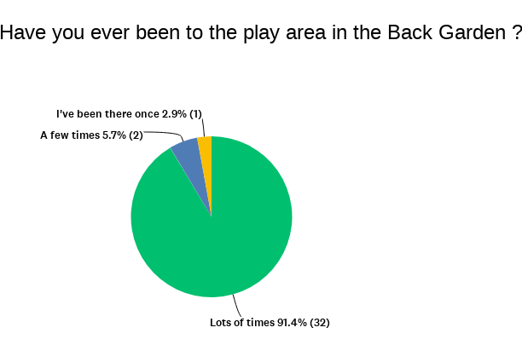
Most are regulars at the Back Garden play area.

To help us think how the bigger additional space could be used, we asked what they liked best about the current play area which makes excellent use of the limited space at the Back Garden, with the dedicated play area at the top end and creative use of the rest of the Back Garden space.

Most were enthusiastic about lots of aspects of the play area and ticked multiple boxes. They told us that what they like best is:
Being able to play outdoors safely 83% 29
Space to run about 80% 28
Playing on the equipment 74% 26
Joining in activities 71% 25
Making fires 71% 25
Making new friends 71% 25
Making things 63% 22
Cooking 57% 20
Play leaders 57% 20
One other responses was: Learning about taking care of our planet (litter picking, COP26 art) gardening.
33 of the 35 respondents think it is a good idea for the community to own more land to make a bigger outdoor play area; the other 2 were not sure and ticked ‘don’t know’.
They gave us a big list of reasons why it would be a good idea:
- To be more safe
- Because the more space we own the more games we can play
- Because you can do much more
- Yes, because then more people can come to the Back Garden and then you can make more friends
- Even more space to run about and MORE FIRES
- Because it would be more fun. We could play tag. There's more space to hide.
- It would be more fun and I could do more stuff.
- It is a good safe place for kids to play.
- It would be more space to play.
- We can have more activities.
- So that more people can play as there will be more space
- More space means more people in the area can use the space, come together in the community, both young and older.
- When the space is larger, even families would like to come to the garden and enjoy.
- So we could have more space to build stuff
- Why not?
These comments were reflected in the next question which asked what they would like to have in a new bigger play area to make it better for the community.
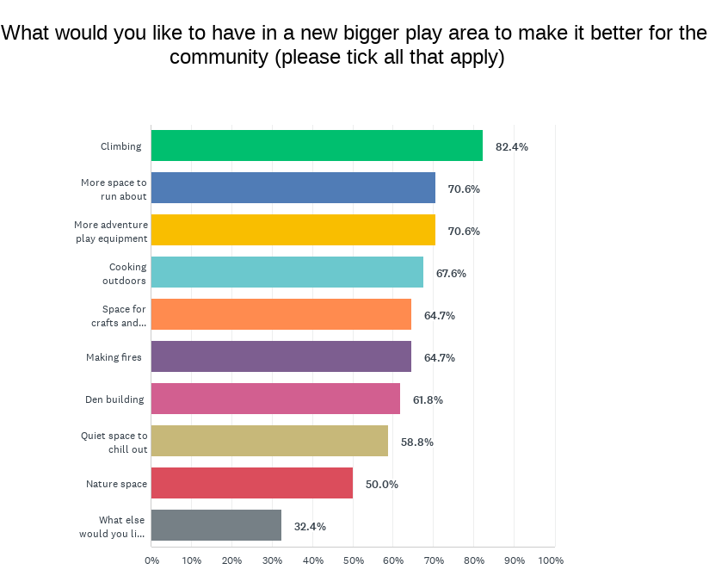
Again they ticked multiple responses:
Climbing 82.4% 28
More space to run about 70.6% 24
More adventure play equipment 70.6% 24
Cooking outdoors 67.6% 23
Space for crafts and woodwork 64.7% 22
Making fires 64.7% 22
Den building 61.8% 21
Quiet space to chill out 58.8% 20
Nature space 50.0% 17
They had a few more ideas about what else they would like to have:
- Play equipment
- A field to play games in
- Ant cage and ladybird cage
- Zip line
- Zip lines to play on outside
- More sports
- A tank that's red and yellow. They are my favourite colours.
- A big chute like the one at the Canal
- Loads of equipment built from real wood that encourages kids to take risks safely
- Growing fruits and vegetables
- I'd especially like more fire.

How would a new big outdoor play area make life better for you? (Please tick all that apply)
It would let me try new things 81% 26
It would let me make new friends 78% 25
It would make me healthier 75% 24
It would get me out of the house 72% 23
It would make me happier 72% 23
I would learn new skills 69% 22
It would make me more confident 63% 20
One other comment: I wouldn't need to travel far for outdoor activities which will help me to save money e.g. transport money and gym.
We asked what other activities they currently do. Most play outside with friends and do a number of other activities as shown in the chart below. It’s good to see that most of them are not hanging about feeling bored.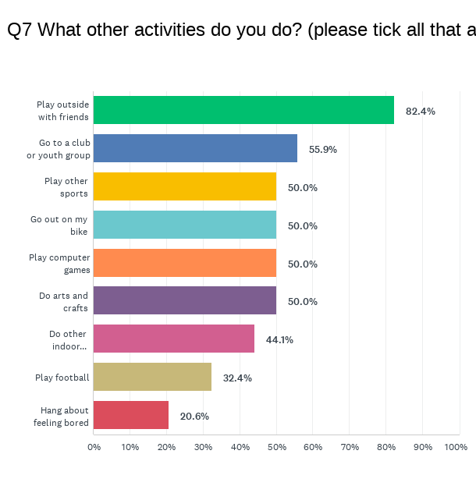
Comments on other activities included:
- I go to dancing. I sometimes go to my garden but sometimes there's a boy who hits me and always hates me.
- I play i-pad.
- Get bored if I'm stuck in the house
There was space for other comments at the end which they used to say:
- Myself and family love the back garden, been going since we moved into the area. Lovely place to go and meet new people, grow our veg and there is always activities to do. 😁
- In Possilpark area there is only one play area, which has only one slide and small swing. Having another addition will be helpful to the families, especially those with young children.
- That there are more areas to plant, this is good
- Love the back garden!!! The community love the back garden so more space brings more people, if lockdown taught us anything. It’s great to be outside!!!

Stakeholder interviews
A number of key stakeholders were contacted to ascertain their views on the proposed acquisition with a view to gathering opinions and identifying potential usage of either site or future partnership opportunities.
They were asked the following questions:
- Do you think Concrete Garden should purchase either or both of the sites?
- How do you think this could benefit the community?
- Would this development benefit you as an organisation? Would it create opportunities for your organisation, for use of either the revamped Back Garden or the play space?
- Do you have any other comments that you want to share?
The following responses were received:
Young People’s Futures
I think the Concrete Garden should purchase both sites as they are both very different sites but equally important and needed in the community and it would serve the community better being managed and owned by a local project.
The Back Garden do an amazing job already and I think it's really important for the community that young people have a safe place to play and outdoor play is a vital part of that.
This would definitely benefit us as an organisation as we can both use each other's sites hopefully and learn from each other. Another place for young people to go to can only be a positive.
I believe that we as an organisation could use this space to send volunteers or parents that want to be more involved in that type of thing.
Boom Community Arts
Absolutely. Concrete Garden should purchase the sites. The Concrete Garden and Back Garden are key community spaces in Possil, and the purchase would give them a security and sustainability that is much needed, and would allow them to develop their services in the community.
How do you think this could benefit the community?
The spaces offer something that simply does not exist elsewhere in Possil. Having visited the sites whilst in use (for example, one of our Christmas activities brought Santa to the Back Garden last year to visit, and we have delivered art activities at their events), I have seen first-hand how much children and young people in the area get from being able to use this site. Similarly, I know how valuable the growing space is to people in the area. Having spaces/resources like this are key to developing healthy, resilient neighbourhoods and communities.
Proximity to derelict land is bad for wellbeing, so I would support this proposal as a way to productively use this land to increase wellbeing in the area. With the increase in new housing being built in the area, it is absolutely crucial that community resources be developed too.
Would this development benefit you as an organisation?
As an organisation without premises, we often rely on community spaces in which to deliver activities. A part of our operation is also concerned with adding value to existing events and activities by providing art activities where our funding allows. So, in that respect, having more options would certainly benefit us.
As part of a network of community organisations in the area, who often collaborate, what is good for one of us is often good for all of us!
Other comments - I'm delighted to lend our voice to support this project
Community Engagement & Development Office, Glasgow City Health and Social Care Partnership (HSCP)/North West Locality
Do you think Concrete Garden should purchase either or both of the sites?
Yes. For the Back Garden it would give greater control over the investment they already have there. Taking on the other site as a play area would maintain a green space, create an amenity for the new housing and prevent the vacant space becoming a dumping ground. It also makes sense as it would allow the expansion of the play area and activities which are currently restricted by the size of the space in the Back Garden.
How do you think this could benefit the community?
GCC is not going to take either site on so, as a community asset, the sites would be controlled by the community. There are always safety issues with vacant /derelict land. Having it in community ownership means it is no longer a dead space which improves safety for everyone in the community. Ownership would also allow access to funding.
There are the obvious benefits to health from access to greenspace and to children’s wellbeing from being able to play safely outside. This benefits the people in the new housing, as well as the existing community and could help integration.
It would be great if the play site could include an area where young people could gather and chat but it’s also important to retain access for local people who use it as a cut through, to walk dogs, etc.
It might be possible to extend the cycle path so that it becomes part of an active green corridor, encouraging green travel as well as spending time in green space, and linking with Claypits.
Would this development benefit you as an organisation?
Referring people for activities in the Back garden to help mental health and wellbeing fits better with the Health Centre than with the PCHP. I know Concrete Garden and the Health Centre worked well together pre-Covid. The Link Workers employed by the GPs are more likely to be involved with social prescribing so it would be worth speaking to the Link Worker. Those involved in social prescribing are looking to work with established organisations with a good track record, like Concrete Garden, rather than short-term projects which disappear with the funding. The play area could offer support for young families, as well as the children themselves.

Barmulloch Community Development Company Ltd
As community connector for the area for the past 4 years, I would back any ideas which enable our community to develop land for the local people’s benefit. I think both sites should be purchased and kept for the community to use in the future.
If Concrete Garden cease to use the space then it could be donated in future to another community not for profit group.
How do you think this could benefit the community?
It will keep green and play space in the local area and reduce vacant derelict land. A park like the park in Glasgow Green would be ideal for the site as it is large enough and would bring people from all over Glasgow and also create space for the new housing on the way from Queens Cross adjacent to the land.
Growing space could also be extended and this will enable more local people to grow and use the raised beds.
Would this development benefit you as an organisation?
Yes, it would benefit various organisations I support and also create more positive green / tranquil community space in a street just off one of the busiest streets in North Glasgow – there are about 14,000 cars going up and down Saracen Street a day and this area will benefit the community as they get past the busy hustle and bustle of the main street.
Other comments
Great idea and I support any opportunities to keep community spaces for local people for their benefit.
Well done to your board and management and staff for the great work they do in the community of Possilpark. Good luck with this. I hope there are not too many hurdles in the way and the place can flourish.
Possilpark BID co-ordinator
As the consultant for Possilpark BID, she has been meeting traders, carrying out consultation events, working with architects on designs for shop fronts and on environmental projects, as part of the creation of the Possilpark BID. After a successful ballot, the new Board has been set up; they will take on the implementation of the BID business plan with the help of a new BID manager (being recruited for a 1 day/week post).
Possilpark will be one of the smallest BID areas and will focus on 3 main areas:
- The Crime & Grime agenda – the focus on reducing waste and encouraging reuse and recycling fits with what Concrete Garden does.
- Enhancements to improve the look of the area – shop front improvements; year round lighting; planters and hanging baskets
- Acting as a collective voice for local businesses
The BID will allow access to Scottish Towns Partnership funds which is a route that channels significant amounts of funding to local areas. This could have been a funding route for Concrete Garden if within the BID area. Note: the map shows that the BID area covers the Health Centre but stops just short of the Back Garden.
The Levelling Up agenda is also likely to bring in significant sums of funding to Possilpark so it would be worth looking for links into this, through Councillors, etc.

Other comments
Concrete Garden are fantastic and do amazing work and, with more people in the new housing, there will be opportunities to do more. It would be a no brainer not to purchase the land and retain it for the community. The BID would be happy to provide letters of support if that would help.
She has great faith in Mo and Concrete Garden and confidence that, if anyone can make it happen, they can.

6. Synergy and Impact
This section reviews opportunities to develop Site A, the Back Garden’s impact and resilience holistically with plans for Site B.
It considers the synergy between planned projects on the 2 sites in terms of:
- Operational and financial impact on Concrete Garden as an organisation
- Impact on the community i.e. how the larger scale and wider scope of activities on the 2 sites can jointly make a bigger difference to people’s lives.

Organisational impact
All of the projects that make up the Concrete Garden have developed in response to listening to community needs, starting with the activities in the Concrete Garden and then expanding into the Back Garden and adding on the play area activities.
Most organisations tend to specialise in one or the other so the two might not seem like a natural fit, but anyone who has visited the Back Garden cannot fail to see the synergy between the different strands of the project. Many of the young people come into the Back Garden as youngsters with parents or grandparents, with opportunities to help or just play safely. Coming into play sessions is a natural progression for some and an introduction to the garden for others. The young people use not just the play area but the whole of the Back Garden imaginatively during the play sessions. The Back Garden has space for them to run around and play and the young people treat it with respect, playing freely but not damaging any of the plots or growing areas. Many are also still involved in growing.
The synergy is what makes the Back Garden successful as a real community space and Concrete Garden successful as an organisation that is truly rooted in its community.
Staffing
Operationally there are staff members specifically employed to support the growing aspects and play staff to provide the play activities. However the management and finance and admin support is shared; this makes sense and, although there is a need to increase management capacity (see the next section), there are savings from having shared central services.
The synergy between the growing and play activities also increases the number and range of volunteer opportunities, and makes it more attractive to young volunteers, including those that have previously been part of the play project. More volunteering options and bringing volunteers of all ages together results in a better experience for volunteers, peer learning and increased community cohesion.
Progression route
The aim would be to use both projects to create a progression route for young people which gives them a better pathway and opens up potential funding to support the roles:

Youth volunteers – training, Duke of Edinburgh awards

Youth apprenticeship – funded
College placements
SVQ accredited training – in community development, community gardening, and outdoor play
Concrete Garden benefits as an organisation by having a bigger pool of enthusiastic volunteers who can develop skills and confidence and help paid staff to deliver a high impact project.
In terms of funding, it could be argued that separating the activities would make it easier to secure funding as it would allow two bites of the funding cherry. However the reality is that many of the funding streams are specific to one or other of the activities so are already available. For the larger funders, the package of activities and the reach into the community that having the two projects integrated within one organisation is a big plus, as the synergy increases the impact on the community.

Positive community impact
The holistic approach in terms of projects and events is a strong suit. The charity caters to many needs, from providing a natural outdoor play area for children to providing a safe space for vulnerable people.
The increased space will allow an expansion of the food and growing activities, more social activities and more volunteering opportunities.
It will have a major impact on outdoor play. With 350 children registered to play and numbers increasing year on year as the house building in the area continues, the play space in the Back Garden is no longer big enough. Expanding into the new area will allow for an increase in numbers and a greater scope for imaginative play and use of the space.
The synergy between the projects increases the impact by better tackling the socio-economic issues identified by consultation and working with the community:
- Lack of activities and neutral outdoor spaces where people can integrate, meet friends or connect with neighbours and become involved in the social and cultural life of Possilpark. Residents need somewhere accessible, alcohol free, and affordable to get to know others.
- Lack of transition support services. Across the community and the wider city there are adults going through trauma, rehabilitation, addiction recovery or transitioning from prison/residential care. They need more person-centred opportunities that offer continuity and connection throughout and beyond transition.
- Lack of quality, accessible volunteering opportunities. There is a need for more opportunities that remove financial, personal and social barriers to inclusion for volunteers.
- Lack of safe places for children to go outdoors to meet their friends. Childhood in Glasgow is not equal. Kids in the community have no safe place outdoors to meet their friends, have fun, be wild or get away from their day to day challenges. The play space and Back Garden reduce the barriers to outdoor play and increase access to free, quality outdoor opportunities.
- Limited availability of food growing space and lack of dignified food provision. There are high levels of food poverty locally. Many had never had an opportunity to develop the skills to grow or prepare fresh foods.
Both projects embody and support positive climate action through the principles of permaculture; Earth Care; People Care; Fare Share. These principles seep into everyone and everything – from play to social gardening and community events.
These projects have been designed by, with and aimed at the residents of Possilpark, and the wider Canal Ward area, including adults, the elderly, children, young people, BAME and families. The principle is not just of listening but of actively involving local people in co-design which will be the basis for the upgrade of the Back Garden and the development over time of the play space.
The acquisition of the two sites will ensure that these activities rooted in the community can continue to listen to and work with the people in the community to use the space to address some of the challenges that they face on a daily basis through solutions that they have worked out for themselves.

7. Ownership and Management Model
This section considers the ownership and management model, assessing the risks associated with community ownership and management of both sites, separately and together.
It also looks at amendments that may be required to the constitution and the Board structure.

Fit with charitable objects
Concrete Garden was constituted on 9th February 2010 and registered as Scottish Charitable Incorporated Organisation (SCIO) SC043154 from 15th May 2012.
Its charitable objects are stated as:
To promote for the benefit of the public the advancement of citizenship, civic responsibility, sustainable community development and urban regeneration of the community of Possilpark and the wider North Glasgow Area
4.1 To provide recreational activities with the object of improving the conditions of life for the persons whom the activities and facilities are intended
4.2 To advance environmental protection, improvement and education to all people.
Membership is open to any individual aged 16 or over who wishes to support the aims and activities of the organisation. All members are expected to comply with the ethos of the garden and agree to conditions as set out in the garden members’ handbook.
To be eligible for Scottish Land Fund stage 2, there would need to be changes to the constitution to:
- More clearly define the specific operating area e.g. as Canal Ward or by G22 & G21 postcode areas
- Redefine "Ordinary" membership as open to people resident in this specific operating area
- Ensure that at least 60% of Board members are resident in the Canal Ward. Although most have an interest in the area, few of the current trustees live in ward. The maximum number of trustees is currently 12, elected annually at the AGM.
The intention is to bring a resolution to the members to define the geographic community as Canal Ward and bring a minimum membership to 20, with a majority of membership from the geographic community, along with minimum 60% majority of Trustees. Article 14, which states the board may, at its discretion, refuse to admit any person to membership, will be removed.
These changes may not be required if the acquisition can be achieved through a negotiated sale, with the purchase price funded through a funder other than the Scottish Land Fund.
The constitution does not include clauses giving the Board the power to co-opt non-members onto the Board e.g. to bring in specific skills or experience, or some of those who do not live in Canal Ward. This should also be considered as a useful way of bringing additional expertise to the Board.

Board and management skills
Concrete Garden is governed by a board of 7 volunteer trustees made up from a diverse group of people, with representation from protected characteristic groups, local people, and an age range from 23 to 65. They bring a wide range of skills and expertise to ensure effective governance and oversight of the organisation and its activities.
Work is ongoing to enable community representation at board level through a number of working groups and focus groups - ensuring each group, including the young people, has agency to shape the future direction of projects that matter to them.

Management and staffing
The diagram below shows the staffing structure (current and proposed) for the whole organisation, including the Back Garden and the play services:
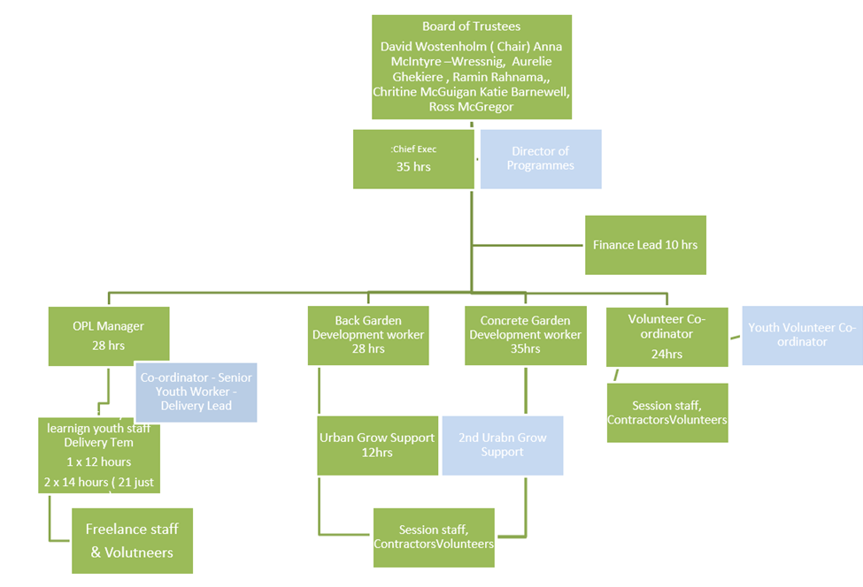
Current staffing
Chief Executive, Moira Ann McCormick has worked in a community development capacity in Possilpark since 2003. She has a long-standing family history and cares passionately and deeply about this community. She has developed a small growing project into the successful charity that Concrete Garden is today. As Chief Executive, she is responsible for strategic development and planning as well as managing the day to day operations and the staff team, securing funding and managing the finances. She has the full range of skills required to manage the land acquisition, subsequent site development and the expanded project. The new role of Deputy Chief Executive will increase operational management capacity and give her time to take a more strategic focus.
The Back Garden Development Worker is responsible for managing the space and overseeing the growing activities, ensuring that people are welcome, supporting participants and volunteers, co-designing and delivering training and workshops, monitoring outcomes and providing support and supervision to community growers and volunteers.
Sessional staff and freelancers are brought in, as required, to provide specialist skills in a wide range of areas - multimedia art, art therapy, free play, horticulture, permaculture, medical herbalism, textile design, woodwork, architecture, cookery, mindfulness, meditation and self-care.
Outdoor Play and Learning Delivery and Development Managers - A review of the play project staffing and management led to the decision to develop an alternative play leadership structure. This is now a split role – with one manager responsible for Development and another for Delivery - creating a sustainable and resilient leadership model with individual focus on either the more strategic aspects of development, or on leading on the delivery of play services and supporting the play team on a day-to-day basis.
The Play Team staff members each have unique skills in child-led community development, Forest School, Autisms, bereavement, supporting additional needs, and skills in carpentry, cookery, arts and craft and horticulture, drama.
Other staff work across the whole organisation.

Recommendations
- There is already the intention to bring a resolution to a members’ meeting to make the changes required to the SCIO constitution to meet Scottish Land Fund’s eligibility criteria.
- Work to increase meaningful community representation is also already in hand.
- The staffing structure in its existing form, split into play services; gardening and volunteer development makes sense in terms of ensuring good governance and operational management. The structure should continue to be appropriate to support the increased scale of activities and additional delivery staff that the land acquisition will allow over the coming years.
- The proposed acquisitions create exciting opportunities to deliver more for the community. It is recognised that additional hours/posts will be required to make the most of the garden spaces and develop the play services. Some of the additional posts/hours are needed now; some will be required over time as activities making use of additional space are developed. Additional posts require additional funding but delivering more means achieving more outcomes and increasing the reach into and impact on what is statistically a very deprived community. The synergy between activities and the increased impact that comes from this means that projects are likely to continue to appeal to funders.
- Capacity to support an increased number and range of volunteers will also be kept under review, as will any need to increase admin and finance hours to be able to cope with increases in the workload.
- The Board has already agreed to create an additional post of Deputy Chief Executive/Operations Manager (shown in blue on the staffing diagram above as Director of Programmes) to take over some of the tasks and responsibilities currently part of the Chief Executive’s role. This will include HR, support and supervision, some of the funding work and other operational tasks, which will free up the Chief Executive’s time to focus on strategic planning, relationship building and asset acquisition. Recruitment for this post is underway.

8. Finance and Funding

Financial performance
Concrete Garden have been successful over the years in attracting funding, often multi-year project-specific grants from the National Lottery Community Fund, Glasgow City Council, Children in Need, Robertson Trust, Garfield Weston Foundation, as well as a range of other funders. This has allowed them to develop their spaces and activities and given a measure of financial security.
Income remained fairly steady over recent years with an increase in 2020/21 due to additional grant income to support the community during Covid:
Year-end Income Expenditure
31 Jan 2018 £246,541 £242,273
31 Jan 2019 £254,172 £218,599
31 Jan 2020 £203,411 £226,543
31 Jan 2021 £291,428 £226,583
31 Jan 2022 £280,949 £254,560
The costs break down as 70% staffing; 25% project and direct delivery costs; 5% overheads.

Projected operational costs
The budget target for the current year to 31st March 2023 is £256,264 (excluding the proposed land acquisition). This breaks down to £62,369 for organisational/management; £65,408 for play; £78,926 for gardens (Back Garden and Concrete Garden); £28,215 for volunteer support; and £21,346 for specific projects.
Expenditure for next financial year (2023/24) to continue at the current level of activity is projected at £298,951, increasing to £301,441 in 2024/25 and £303,955 in 2025/26.
Staffing costs
- Salary costs for the Chief Executive are covered by funding from a number of funders. The additional post of Deputy Chief Executive/Operations Manager, as detailed in the previous section, is being recruited to allow the Chief Executive to take a more strategic focus and deal with the land acquisition and subsequent development work. This new post will be covered initially from reserves but will need to be built into future funding applications.
- Back Garden - £75,000 currently covers staffing plus volunteer support, training, events, etc. Note that the Development Worker post is currently half Back Garden; half Concrete Garden.
- Ideally staffing for the Back Garden after acquisition would be a full time development worker post (covering project management, planning, funding, reporting, etc) + a full-time post for practical work + sessional staff. This would increase the budget to nearer £100,000.
- Play project - Big Lottery and Children in Need funding of £55,000 currently covers 40 hours playworkers + 28 hours management.

- The bigger site will increase the budget required to £125,000-£150,000 to cover:
  - 1 Play Delivery Manager - 28 hours/week
  - 1 Play Development Manager – Increased from 14 to 21 hours/week
  - 4 playworkers – Currently 21 hour posts but increased to 28 hour posts to run more sessions. This is the staffing ratio required to ensure that the young people (some boisterous or hyperactive) get the individual attention they need.
  - Pool of sessional staff – budget £12,000
  - Food - budget of £7,500
  - Materials, workshops, specialists and excursions - budget of £7,500
- One of the new playworker posts could be New Deal or Modern Apprenticeship play trainee (starting at age 16) which would create a training opportunity and bring funding to (part) support the post.
These costs will be confirmed and fleshed out in the financial projections that will form part of the business plan.
Core costs are covered until 2023 by current funding from:
SECURED INCOME 2022/23 | Secured | Project | Salaries | Projects | OH/Man
TNL Community Fund (final of 3 year funding) | £49,924 | Gardens | £37,642 | £6,050 | £6,232
Children In Need (ends Dec 22) | £25,598 | Play | £24,398 | £1,200
Youngstart (2022-23) | £30,234 | Play | £24,383 | £650 | £5,460
GCC Communities Fund 2022-23 | £66,834 | Org Wide | £56,800 | £5,700 | £4,334
IFP VSF 2022-23 | £13,000 | Volunteer | £7,285 | £4,310 | £1,405
Year Of Story | £4,960 | Org Wide |  | £4,960
Garfield Weston 2022-23 | £25,000 | Org Wide | £22,000 |  | £3,000
HFF 2022-23 | £15,956 |  |  | £15,956
Inspiring Scotland Cop | £12,955 | Play |  | £12,795 | £160
Robertson Trust 2022-23 | £15,000 | Org Wide | £15,000
Area Committee | £9,000 | Play |  | £9,000
SLF Stage 1 | £11,826 | ALL |  | £11,826
GCVS wellbeing fund | £7,480 |  |  | £6,800 | £680
TOTAL | £287,767 |  | £189,665 | £79,247 | £21,272
As with all organisations, some applications were unsuccessful - Youth Scotland 2022/23 for play services; CSGN for garden activities and the Tudor Trust for organisation/management costs.
An application has been submitted to the Investing in Communities Fund, to build in additional project management capacity through the creation of a dedicated post to work with the Chief Executive and lead on the findings of the Stage 1 development funding including implementation of the 5-year business plan and fundraising for initial revenue costs, capital costs for design/build of the facilities, ongoing revenue and maintenance costs for the projects based on one of both options. A decision on this is expected by the end of the year and funding would be for the 3 years from 1st April 2023- 31st March 2026.
Children in Need will have new grant rounds at the end of 2022 for the 3 years from April 2023 - March 2026 which would be an option for continuation funding.
The funding uncertainties facing the sector as a whole mean that Concrete Garden, like all other prudent charities, is looking at ensuring that it maximises impact from the funding available. It is confident that as a charity, it represents good value for money. Options to continue to operate effectively if funding comes under pressure have been considered e.g. switching to 4 day/week posts at an increased salary rate (to offset the rising cost of living). These options form part of Plan B which they are confident will not need to be implemented.

Potential income generation
Aspirations to trade are higher in the long-term through the acquisition of the land which will generate some income from services or rents from tenants. It is recognised however that most of the income will continue to be from grants because of the nature of the core services and the beneficiary needs. The intention is to continue to deliver core services for free, vital when so many families in the community are struggling financially or facing economic hardship.
Given the current economic uncertainty, other organisations are supportive of Concrete Garden’s ambitions to take on the additional play space and can see future opportunities for making more use of the space but it is too early to identify any definite interest.
Income generation will take time to develop and build but could come from:
- Garden workshops – targeted at individuals in the leisure market who can afford to pay a reasonable charge or at other organisations able to pay (either from funding or their own income)
- Small sales of seasonal produce through a pop-up stall in the Back Garden or at other community events or venues
- Workshops for small groups of disengaged pupils from local schools, paid for through Pupil Equity Funding (PEF)
- Renting outdoor space, either in the Back Garden or the new play site to other organisations for their own activities
- Play services are currently after school but there is potential for day-time use e.g. childminders, nurseries or other community groups who can pay either for staffed activities or for use of the space for their own activities
- Training other playworkers in skills like fire skills, woodwork, etc
- In the longer term, there is potential income from training courses as an SVQ centre
These are all likely to be small amounts to supplement rather than replace grant income but, together with fundraising, will contribute to sustainability and demonstrate to funders a willingness to consider income generation.

Capital costs and funding
The acquisition and development of the land for the proposed expansion will require capital funding. The valuation was £20,000 for the small Back Garden site A and £80,000 for site B, the bigger site to be developed as the new play area.
Site acquisition
The following have been identified as the most likely potential sources for the capital funding for the acquisition costs:
Scottish Land Fund has already provided stage 1 development funding. A stage 2 application for the cost of land acquisition can fund up to 95% of the valuation price, plus reasonable professional, title mapping and legal fees associated with the purchase.
Organisations must be community-led, community-controlled and defined by and representative of a geographic community with a defined boundary and a clear link between the opportunities provided by the asset and the identified needs of the community.
Successful applicants have to clearly demonstrate that their project will help their local community to:
- achieve more sustainable economic, environmental and/or social development through ownership of land and buildings
- have a stronger role in and control over their own development
- own well managed, financially sustainable land and buildings
Priority is given to applications that can demonstrate significant positive impact for the community as a whole. Concrete Garden should be able to demonstrate this fully.
https://www.tnlcommunityfund.org.uk/funding/programmes/scottish-land-fund
Community Ownership Fund is the UK government’s £150m fund to help community organisations take ownership of threatened community assets.
Community groups can bid for up to £250,000 matched funding to help them buy or take over local community assets at risk of being lost, to run as community-owned businesses. There is no definitive list of eligible assets (communities to set out what matters most to them) but could include community-owned sports clubs, sporting and leisure facilities, cinemas and theatres, music venues, museums, galleries, parks, pubs, post office buildings, and shops.
Note that the fund will provide up to a maximum of 50% of the capital costs to purchase (and renovate and repair) the community asset so would need to be match funded but could include costs to upgrade the Back Garden and/or develop the play area.
Projects should be focused on place-based assets or amenities, important to the local community, which build connections between people and foster a sense of pride in the local area – but are at risk of being lost without community intervention. The purchase of the 2 sites should fit with these criteria.
There is a 2-stage application process with an Expression of Interest as the first stage where they decide if projects can go forward to make a full application.
https://www.gov.uk/government/publications/community-ownership-fund-prospectus/community-ownership-fund-prospectus
Site development
Post-acquisition capital funding will be required to develop/refurbish the Back Garden area and develop the play area to include basic infrastructure - water connections, composting toilets, solar/wind turbine for electricity. The design will be done in-house with professional input only where required, using recycled materials whenever possible. This work will be done in stages over a number of years, depending on funding availability and capacity to work with community and manage the development.
Several major funders are currently reviewing funding priorities and strategies. Securing capital development funding will be an ongoing task and funding streams will change but some suggestions include:
The National Lottery Heritage Fund may be an option for the development and build stages. It provides a range of grants for heritage projects that connect people and communities to the national, regional and local heritage of the UK. Heritage can be anything from the past that the community values and wants to pass on to future generations.
Grants £10,000 - £250,000 (max 95%) can cover a range of costs including capital costs, costs of improvements, and legal fees.
They prioritise heritage projects that:
- promote inclusion and involve a wider range of people (a mandatory outcome)
- boost the local economy
- encourage skills development and job creation
- support wellbeing
- create better places to live, work and visit
- improve the resilience of organisations working in heritage
All projects must also consider long-term environmental sustainability.
https://www.heritagefund.org.uk/funding/priorities-national-lottery-grants-heritage
Potential smaller match funders include:
The Clothworkers Foundation - Open Grants Programme: This fund awards grants towards capital projects which include buildings: purchase, construction, renovation or refurbishment. This does not specifically exclude temporary structures or land development.
Applicants must be able to demonstrate that the work fits within one or more of their programme areas, and that at least 50% of service users benefiting from the capital project are from one or more of their priority groups - including disadvantaged minority communities; disadvantaged young people; people with disabilities; prisoners and ex-offenders. https://www.clothworkersfoundation.org.uk/
Robert Barr’s Charitable Trust – Causes supported include the provision of recreational facilities. The Trustees tend to favour capital projects rather than running costs. No indication of amounts but likely to be small. Trustees meet annually in March. The fund is administered by Jackie McLaren at Dentons, Law Firm in Glasgow. To apply, call Jackie on 0141 271 5357.
Other potential capital funders mentioned at earlier stages but not currently available include:
- The Robertson Trust’s Community Buildings Fund which closed to new applications on 30th November 2021
- The STV Appeal works with experts in the field of child poverty to identify partner projects, rather than operating an open grant making model works
Loan funding, even as a last resort to plug a funding gap, would be problematic as this would require income generation to make the loan repayments. One option might be Social Enterprise Net Zero Transition Fund delivered by Social Investment Scotland (SIS), in partnership with Zero Waste Scotland, and designed to support social enterprises and the wider third sector to make the transition to carbon net zero.
The purpose of the fund is to support organisations in their journey to become carbon neutral, and to develop the circular economy. Through the fund, they are interested in supporting activities that will reduce carbon footprint such as: reducing energy consumption; improving energy efficiency; developing or moving to renewable energy sources; scaling local food production and supply; minimising or re-purposing food waste; and developing circular economy products, services, processes and practices. Please note this is not an exhaustive list and they are keen to see a range of activities come forward.
The fund provides loans from £10K - £1.5m, and organisations who have a particular circular economy focus or are proposing specific projects with a focus on re-use, repair and leasing/sharing models, may also be eligible for a small grant award up to £20K.
https://www.socialinvestmentscotland.com/learning-hub/social-enterprise-net-zero-transition-fund/
Preferable alternatives to plug funding gaps could include traditional fundraising, crowdfunding or seeking corporate donations, although it is recognised that none of these are easy options in the current economic climate, especially in an area of deprivation.

Revenue funding
Concrete Garden has been successful in securing revenue funding over the years so is well aware of the funding criteria for the main funders. Below are some initial suggestions for potential sources of funding that are currently available:
Funder | What they will fund
The Henry Smith Charity Strengthening Communities  https://www.henrysmithcharity.org.uk/explore-our-grants-and-apply/strengthening-communities-grants/strengthening-communities-overview/ | Grants of between £20-60K per year for up to three years are available to community-led charities and not-for-profit organisations working to support communities in the most deprived areas of the UK.  Focusing on supporting the running costs of organisations working at grass-roots level, to ensure that funding reaches the most disadvantaged areas, targeting places that are economically marginalised and affected by poverty.  Funding could be used to increase existing service provision, take on a new staff member, improve sustainability or cover small capital costs.
Garfield Weston Foundation  https://garfieldweston.org/ | Supports a broad range of organisations and activities which share a commitment to making positive impact on the lives of the communities in which they work, and driven by a desire to achieve excellence.  Grant categories include Education; Youth; Health; Community; Environment; and Welfare.
Esmee Fairbairn Fund  One of the largest independent grant-makers in the UK but their new strategies are much more focussed so harder to fit the criteria  Our Natural World | Esmée Fairbairn Foundation (esmeefairbairn.org.uk) | Under the Natural World stream, Protecting and creating more space for nature enables the restoration of damaged ecosystems and degraded landscapes. It's also important that the benefits of being close to nature are accessible to all.  Not that close a fit but it may be an option for some of the Site B work.
Tudor Trust  Currently closed to applications from new organisations  https://tudortrust.org.uk/how-to-apply | Like a number of other funders, they are reviewing their learning from current funding and reviewing their funding strategy.  They will be publishing updated funding guidelines, which will draw on the work they are carrying out over the next year, on 1st April 2023.
Volant Charitable Trust  https://www.volanttrust.org/what-we-fund/ | Supports Scottish charities and projects, whether national or community-based that alleviate social deprivation, particularly supporting women, children and young people at risk.  Specific programme areas include poverty and deprivation which can include mental health projects for women and children; support for vulnerable families; promotion of healthy eating for families in areas of extreme deprivation.

https://www.understandingglasgow.com/profiles/neighbourhood_profiles/3_nw_sector/4_ruchill_and_possilpark?postcode=G22+5PS
https://www.gfis.org.uk/Providers/View/59/G22
Taken from the Cowlairs Masterplan Report, produced by DRS Project Management & Design, published 30 July 2019
From Scottish Community Alliance e-bulletin August 9, 2022
Completed by two undergraduate students from the University of Glasgow, Rosie Convey and Marie-Alix Van Waetermeulen, and funded by the University of Glasgow Settlement as part of the Find a Solution initiative.

